Assets: https://media.wiredproductions.com | Request Code: https://requestkey.net/1zzwtu
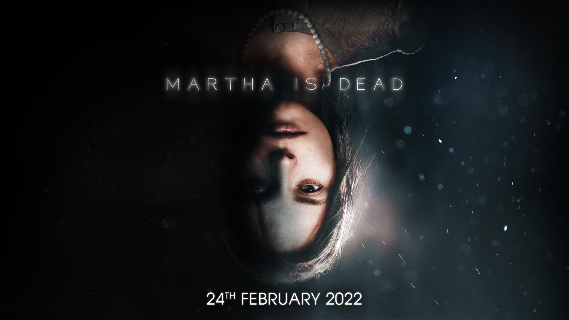
Psychological Thriller ‘Martha Is Dead’ Confirms Launch on PlayStation, Xbox, and PC on February 24, 2022
New Trailer Debuted at Golden Joystick Awards as Physical Pre-Orders go Live
Watford, UK, November 24th, 2021: Global video games publishing label, Wired Productions and leading Italian studio, LKA, can today confirm their forthcoming and highly anticipated psychological thriller Martha Is Dead will launch across PC, PlayStation 4 & PlayStation 5 and the Xbox family of devices on Thursday 24th February, 2022, with pre-orders now available for the physical release.
Built in Unreal® Engine 4, Martha Is Dead combines real-world locations, working in links to historical events during the latter stages of World War II, superstition, folklore, and deep psychological distress. The game opens in the depths of the Italian countryside as Allied and Axis forces turn the nation into a pincered playground.
Martha Is Dead’s latest trailer teases Unreal’s revolutionary ‘Metahuman’ technology in an intimate and immersive showcase of the foreboding tension evident throughout the game. Meet the twins, Martha and Giulia, witness their special bond and get a glimpse of how dealing with the acute trauma of loss can affect a tortured mind.
Check out the trailer here: https://youtu.be/KWRYUz29mK0
“Martha Is Dead has been a long journey for us, but we’re now nearing the point where the whole world will get to play it,” offers Luca Dalco, Founder & Director, LKA. “this is an experience curated to be faithful and accurate to the era, from our authentic recreation of the Tuscan countryside through to the impact that WWII had on Italy. We can’t wait for people to experience the game for themselves.”
A physical version of Martha Is Dead is now available to pre-order on PlayStation 4 and PlayStation 5. Celebrate LKA’s release with an exclusive reversible sleeve, fold out double-sided A3 poster, collectable sticker sheet and a digital download Tarot card pack; based on the cards in-game. Gamers can pre-order their copy today via shop.wiredproductions.com or find a retailer via Wired’s Where to Buy section. PC players can also WishList the game on Steam.
Wired Productions also today unveiled the limited edition Martha Is Dead triple Vinyl Soundtrack, you can register your interest here - more details will be shared on this in the near future.
Martha Is Dead will launch on PC, PlayStation 4 & PlayStation 5 and the Xbox family of devices on Thursday 24th February, 2022, the game is rated ESRB M (Mature), PEGI 18 and USK 16.
Download the embargoed content via https://wired.gg/MID/ZIP. Download all other available assets via https://media.wiredproductions.com/. For more information, follow us on Twitter or join the official Discord.
For PR requests, please contact:
Stefano Petrullo – Renaissance PR
stefano@renaissancepr.biz +44 (0) 7828 692 315
Keith Andrew - Renaissance PR
keith@renaissancepr.biz +44 (0) 7834 237 322
-END-
ABOUT WIRED PRODUCTIONS
Wired Productions is a video games publisher based in Watford, UK. Wired has produced and published award-winning titles across all major platforms for over a decade. Bringing games to market in both physical and digital media, notable launches to date include The Falconeer, Those Who Remain, Deliver Us The Moon, AVICII Invector, Close to the Sun, GRIP: Combat Racing, Victor Vran: Overkill Edition, Max: The Curse of Brotherhood and The Town of Light.
Join the Wired community by tapping these links: wired.gg | facebook.com/WiredPro | twitter.com/Wiredp | youtube.com/wiredp | discord.gg/wiredp | instagram.com/wired_productions/
ABOUT LKA
LKA is a leading and award-winning video games studio based in Florence, Italy. Founded more than 20 years ago and specialising in artistic production across media, LKA’s debut video game The Town of Light received critical acclaim, including a Drago D’Oro award for Greatest Artistic Achievement. Martha Is Dead, LKA’s upcoming release continues the studio’s signature multi-layered narrative style combined with real world locations and will release in 2021.
Martha Is Dead is co-funded by the European Union through the Creative Europe Programme.

