Dive into Lumote: The Mastermote Chronicles on 24 March 2022 on Nintendo Switch, PC, PlayStation 4, Xbox, and Google Stadia
Experience the beautiful 3D puzzle platformer with a PC demo available to play today, alongside the reveal of a Double Vinyl!
Watford, UK – 9th February 2022 – Indie games publishing label Wired Productions and developer Luminawesome Games Ltd., are pleased to reveal that the mesmerising 3D puzzle platformer, Lumote: The Mastermote Chronicles, is to be released for Nintendo Switch, PC, PlayStation 4 and Xbox One on 24 March 2022, with Wired Productions also dropping the news that Lumote: The Mastermote Chronicles will launch day one on Google Stadia! In addition to this, Luminawesome Games have made waves with the surprise launch of a demo version, available now for PC players! Together Wired Productions and award-winning composer Paul Ruskay also unveiled the Lumote: The Mastermote Chronicles Double Vinyl, which is available to pre-order now for £35 / $45.
Lumote: The Mastermote Chronicles expands on the early access PC game, Lumote, supporting Luminawesome to deliver a complete version of the critically acclaimed release that delivers additional story, creates a whole new game world playing as the mighty Mastermote, and includes a new level of challenges, puzzles, and collectibles. With a brand-new gameplay trailer, narrated by Michelle Rocha, developer and co-founder of Luminawesome Games, players are taken on a journey through The Great Depths guided by the curious and adorable protagonist, Lumote. As the trailer dives into the underwater world, players are introduced to the bioluminescent creatures, known as the Motes, who spend their lives deep in the bioverse, content with living on the rhythms found in the electronica soundscape.
Watch Lumote: The Mastermote Chronicles Release Date Announce trailer: https://youtu.be/WVv5EG73ey8
Submerge yourself in the hypnotic soundtrack with the brand-new limited print double vinyl for Lumote: The Mastermote Chronicles, featuring the work of award-winning composer Paul Ruskay as he takes listeners on a majestical electronica journey through the Great Depths. The stunning score communicates through music the key moments and emotional states of Lumote, deep and trance-like, the soundtrack is a monumental adventure from start to finish. Limited to 500 pressings, the Lumote: The Mastermote Chronicles Double Vinyl, featuring meticulous illustrations from artist David Sossella, is available to pre-order now via the Wired Productions store for £35 / $45.
When the shift causes the Great Depths to turn red, the squishy hero, Lumote, embarks on an epic odyssey to return the world to blue. Lumote must possess, jump, and think its way through a world of puzzles. To aid in the quest, Lumote’s ability to possess Motes will help reach areas not normally accessible. For every puzzle Lumote completes opening flower gates, it is one step closer to finding Mastermote!
- Seafoam Moocher Squish, bop, and bounce through the world around you. Lumote is extremely curious, highly inquisitive, and adorable!
- That's one big world! The world of Lumote is a single massive environment with numerous puzzles separated into towers. Each tower marks your mastery of a specific Mote and unlocks a new set of puzzles to explore.
- Solve intricate puzzles Set in a 3D puzzle adventure, clever and logical level design ease players in whilst increasing the complexity with each Mote you meet.
- Gorgeous sounds A stunning score accompanies you, deep and trance-like that will take you on a majestical electronica soundscape journey.
- Luminated game engine Using the original rEngine, Lumote’s puzzles are all interconnected, and you can seamlessly go from one puzzle to the next as you progress.
- Once you complete your first playthrough, switch roles and continue into a whole new world as Mastermote!
“Taking Lumote from its original concept of ‘Bump’ at Game Jam and translating that into the complete Lumote: The Mastermote Chronicles game we have created today has been an experience like no other,” said, Kyle Rocha, co-founder of Luminawesome Games. “Five years later, it feels like a dream to be able to announce the release date, and we can’t wait for players to get their hands on the game!”
“We are ecstatic to be able to reveal the release date for Lumote: The Mastermote Chronicles, while introducing players to the various unique and adorable creatures found within The Great Depths.” Said Neil Broadhead, Head of Marketing at Wired Productions. “At Wired, we are proud to be working alongside the Luminawesome team, supporting and furthering the development of Lumote, while creating an enchanting Vinyl to complete this release.”
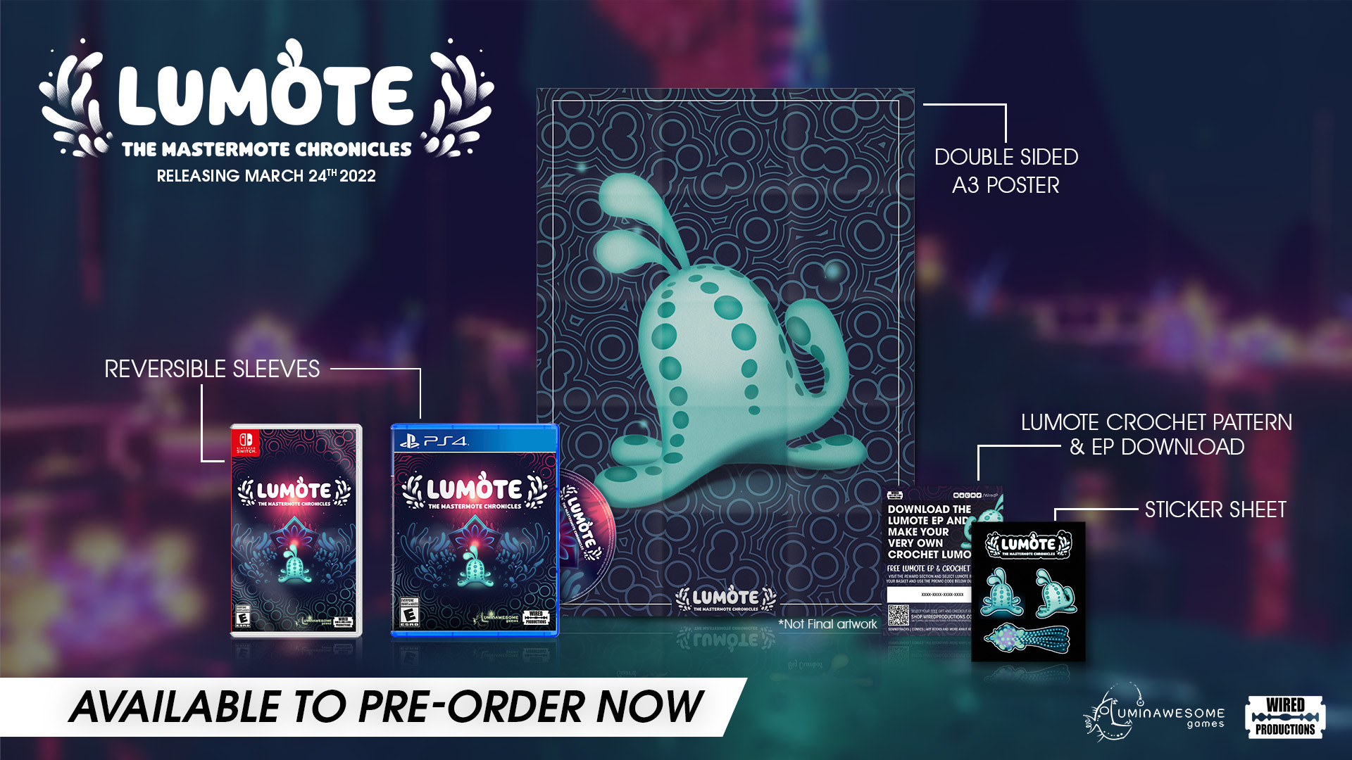
Lumote: The Mastermote Chronicles limited physical edition is available to pre-order via the Wired Productions Store. The Nintendo Switch and PlayStation 4 versions includes a double-sided folded poster, reverse inlay, a unique set of stickers featuring the bioluminescent hero, plus a digital download for the Lumote EP, and if that wasn’t enough, instructions to crochet your very own Lumote. The physical release will be available on PlayStation 4 for €19.99 / $19.99 / £15.99 and Nintendo Switch €29.99 / $29.99 / £24.99.
The Double Vinyl soundtrack for Lumote: The Mastermote Chronicles is available to pre-order now from the Wired Productions store for £35 / $45.
Lumote: The Mastermote Chronicles launches 24 March 2022 on Google Stadia, Nintendo Switch, PC, PlayStation 4, and Xbox One.
For more information, visit https://wiredproductions.com/games/lumote/.
###
For preview code and interview requests, please contact:
Wired Productions
Tegan Kenney | press@wiredproductions.com
Dead Good PR for Wired Productions
wired@deadgoodmedia.com
About Wired Productions
Wired Productions is an independent video games publisher based in Watford, UK. Wired has produced and published award-winning titles across all major platforms and its games are curated to deliver on its mantra: ‘Driven by Passion.’ Bringing games to market in both physical and digital media, notable launches to date include The Falconeer, Those Who Remain, Deliver Us The Moon, Close to the Sun, GRIP: Combat Racing, Victor Vran: Overkill Edition, Max: The Curse of Brotherhood and The Town of Light. Recently, Wired Productions announced its upcoming slate of titles during Wired Direct. Upcoming titles include, Lumote, Arcade Paradise, Martha Is Dead, Tin Hearts, Tiny Troopers: Global Ops and The Last Worker.
Join the Wired community via: Wired Live| Twitter | Discord | YouTube | Twitch
About Luminawesome Games Ltd
Luminawesome’s humble beginnings came from winning an unreal game jam with the initial concept of Bump, which Kyle and Michelle Rocha fell in love with and developed into Lumote. Originally from Cambridge, Ontario, Kyle was recruited by United Front Games to work on Sleeping Dogs. With an ethos of being environmentally friendly and green, this is brought out in the game showing their own creative twist on an underwater world.
https://luminawesome.com/

