Press Kit: https://bit.ly/TLWPress
Review Requests: https://requestkey.net/x85hrk

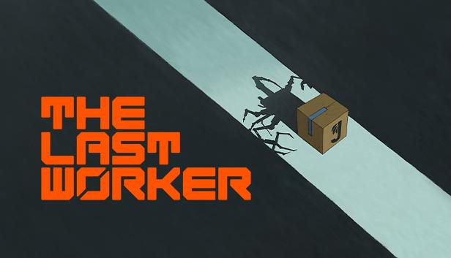

Jason Isaacs, Ólafur Darri Ólafsson, Clare-Hope Ashitey and David Hewlett are the ensemble cast for The Last Worker’s unique blend of immersive narrative adventure, stealth and action gameplay.
World-class talent premiere the award-nominated game at Venice Film Festival

Watford UK, 2nd September 2021: Wired Productions, Oiffy and Wolf & Wood today revealed the world-class talent delivering the inspired narrative in the forthcoming, award nominated adventure, The Last Worker.
Watch the cast introduction here:
https://youtu.be/eH9-XwIDbdE

Created by Writer / Director Jörg Tittel – and the only video game selected by the 78th Venice International Film Festival (La Biennale di Venezia) – The Last Worker is a first-person narrative adventure centred around our struggle in an increasingly automated world. Combining a hand-crafted art style with uniquely immersive gameplay mechanics in an epic setting, The Last Worker delivers an emotional, thought provoking and comedic story packaged with rich characters performed by an all-star cast:

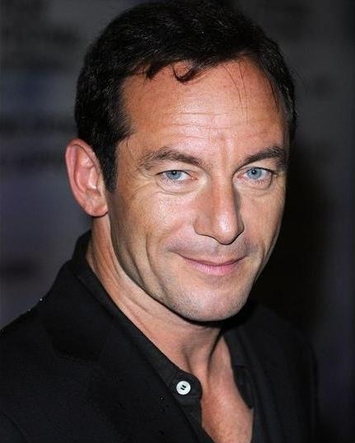
Jason Isaacs (Harry Potter, Star Trek: Discovery, The Death Of Stalin)
as Skew

Ólafur Darri Ólafsson (Fantastic Beasts: The Crimes of Grindelwald, The Meg, The Dark Crystal: Age of Resistance)
as Kurt

Clare-Hope Ashitey (Children of Men, The White King,Shooting Dogs)
as HoverBird

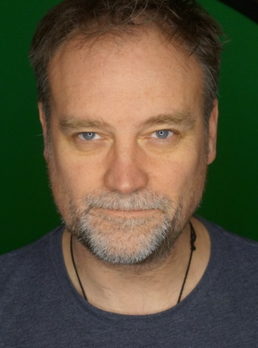
David Hewlett (The Shape of Water, Stargate: Atlantis, Rise of the Planet of the Apes)
as Josef

Jason Isaacs said, “The Last Worker felt entirely unlike every game I’ve played or been a part of. The characters were human and complicated and funny, the story was poignant and personal and, yes, the game-playing was addictive and fun. All round it felt fresh, creative and original. When was the last time you had a helper bot from Liverpool?! The creator, Jörg, is a risk-taking nerd of the highest order. Roll on The Last Worker 2… if that’s not a contradiction!”

Jörg Tittel said, “There is no better occasion to announce our wonderful cast than the world’s oldest film festival, La Biennale di Venezia. We have recorded over 200 pages of dialogue between London, Reykjavik, Adelaide and Toronto and I hope that people the world over will fall in love with their characters and get lost in our story.”

Leo Zullo, Managing Director, Wired Productions, continued, “The Last Worker being the only video game up for an award at the 78th Venice International Film Festival is a testament to how unique an experience it already is for VR and traditional gaming platforms.”

ABOUT THE LAST WORKER
Featuring uniquely immersive gameplay, handcrafted 3D and 2D visuals based on concepts by legendary British comics artist Mick McMahon (Judge Dredd, Batman) and a multi-instrumental score by Oliver Kraus, The Last Worker is playable at the 78th Venice International Film Festival on Oculus Quest 2 / Quest. It is the only video game in the festival, where it is competing for awards in the Venice VR Expanded category.

Releasing on all platforms in 2022, The Last Worker is a narrative adventure centred around our struggle in an increasingly automated and dehumanizing world. Set in lonely, oppressive but strangely beautiful environments, The Last Worker is a unique blend of first-person narrative, work simulation, action and stealth gameplay. Combining a hand-crafted art style with uniquely immersive gameplay mechanics in an epic setting, the game delivers an emotional, thought provoking and comedic story with rich characters performed by an all-star cast.
The Last Worker will be released in 2022 on Oculus Quest 2 / Quest, Steam VR, Steam, Epic Games Store, Nintendo Switch, PlayStation 5 and Xbox Series X/S.

For more information, check out the latest news and wishlist via Steam, visit the official website for The Last Worker or follow on Twitter or Instagram.

###

About Wired Productions
Wired Productions is an independent video games publisher based in Watford, UK. Wired has produced and published award-winning titles across all major platforms and its games are curated to deliver on its mantra: ‘Driven by Passion.’ Bringing games to market in both physical and digital media, notable launches to date include The Falconeer, Those Who Remain, Deliver Us The Moon, Close to the Sun, GRIP: Combat Racing, Victor Vran: Overkill Edition, Max: The Curse of Brotherhood and The Town of Light.

Recently, Wired Productions announced its upcoming slate of titles during Wired Direct. Upcoming titles include Lumote, Arcade Paradise, Martha Is Dead, Tin Hearts, Tiny Troopers: Global Ops and The Last Worker.

Join the Wired community via: Wired Live | Twitter | Discord | YouTube |Twitch

About Jörg Tittel
Born in Brussels in 1978, Jörg Tittel is a London based writer, director and producer. His feature film debut THE WHITE KING starring Jonathan Pryce and Fiona Shaw, which he co-directed with his wife and production partner Alex Helfrecht, premiered at the 2016 Edinburgh International Film Festival, where it was nominated for the Michael Powell Award for Best British Feature. Besides writing and directing THE LAST WORKER, he is currently producing A WINTER’S JOURNEY starring John Malkovich. THE LAST WORKER is his VR debut.

About Oiffy
Established in 2011 by director/writer Jörg Tittel, director/writer Alex Helfrecht and producer Philip Munger, Oiffy tells aspirational, heartfelt, intense and original stories on screen, stage and beyond. Their next feature is the painted animated live music adventure drama A WINTER’S JOURNEY, Helfrecht's adaptation of Schubert's “Winterreise” animated by the artists behind the Oscar nominated LOVING VINCENT. Starring John Malkovich and Martina Gedeck, the film is in pre-production for a 2023 release. Mk2 Films are selling internationally. Oiffy.com

About Wolf & Wood
Ryan Bousfield and his team at Wolf & Wood have created internationally recognised VR titles, including A CHAIR IN A ROOM: GREENWATER (2016), THE EXORCIST: LEGION VR (2018) and HOTEL R'n'R (2020) and have worked on all major VR platforms including HTC Vive, Oculus Rift, Oculus Quest, PlayStation VR and Steam VR. Wolfandwood.co

