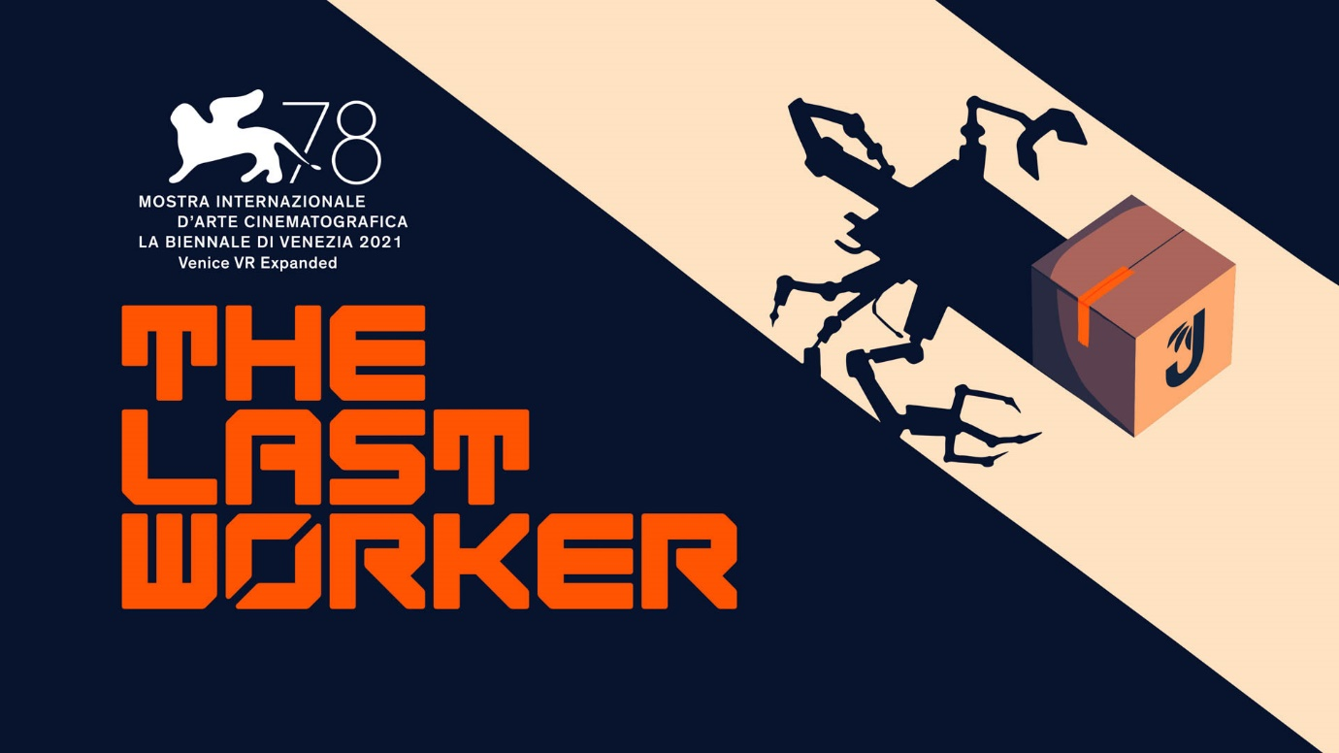
Experience The Jüngle Fulfillment Centre Tour as You’re Invited to Peek Inside The Last Worker for the First Time
Jörg Tittel, Wolf & Wood and Wired Productions Give a First Look at The Highly Anticipated First-Person Narrative The Last Worker, Coming to a Fulfillment Centre Near You in 2022
Watford, UK – January 20, 2022: Global video games publishing label Wired Productions, Writer/Director Jörg Tittel and his production company Oiffy and pioneering independent games studio Wolf & Wood are proud to deliver the first trailer for The Last Worker, welcoming avid gamers to the Jüngle Fulfillment Centre (JFC-1) for the very first time. Dispatching in 2022 on Steam, Epic Games Store, GOG, Nintendo Switch, PlayStation 5, Xbox Series X|S and Meta Quest 2, the satirical trailer offers an initial glimpse at the immersive gameplay and environment found in the first-person narrative adventure.
Like all leading online retailers with nothing to hide, CEO Josef Jüngle gives viewers a once-in-a-lifetime opportunity to tour the cutting edge, 650 million square foot JFC-1. Offering a sneak peek at the people, the technology, and the high-tech algorithms at the centre of Jüngle, with products piled as high as skyscrapers, players can see first-hand that Jüngle delivers the future today.
Watch The Last Worker Fulfillment Centre Tour Trailer: https://youtu.be/I3G0emePHQA
Dispatching to all platforms in 2022, The Last Worker is a first-person narrative adventure centred around humanity’s struggle in an increasingly automated world. Combining a hand-crafted art style from comics legend Mick McMahon, with uniquely immersive gameplay mechanics in an epic setting, The Last Worker delivers an emotional, thought-provoking story filled with heartfelt drama, biting satire and intense action, packaged with rich characters performed by an all-star cast. Starring Ólafur Darri Ólafsson, Jason Isaacs, Clare-Hope Ashitey, David Hewlett and more as-of-yet-unannounced top talent.
"The Last Worker is a true labour of love and I'm lucky to be working with the best creative talent money can't buy," said Writer, Director and Producer Jörg Tittel. "With people like these, one can't help but deliver the goods, but should we fail, I hope Mr. Jüngle can give me a job?"
"We have all become attached to the characters in The Last Worker. Seeing them transition from Mick McMahon's sketches and then brought to life by such amazing actors has been a fantastic process to be a part of.” Said Ryan Bousfield, Creative Director of Wolf & Wood. “I'm extremely proud of the innovative approach taken by our team to create a rich and exciting world that is as immersive on screen as it is in VR. We're looking forward to showing you the first elements of gameplay."
“The Last Worker is a truly unique experience, and we are proud to support both the innovative work of Jörg Tittel and the multi-talented indie studio Wolf & Wood in creating this awe-inspiring title," said Leo Zullo, Managing Director, Wired Productions. “We are excited to formally introduce players to Jüngle and the epic Fulfilment Centre in which the game is set. The intense, surprising, and heartfelt story is one that we cannot wait to share later this year.”
The Last Worker Features:
- Miles of gameplay Hours of narrative, immersive gameplay in an environment the size of the sunken city of Manhattan.
- Heart A unique blend of core gameplay mechanics seamlessly interwoven into a narrative game unlike any other.
- AAA Casting Rich characters performed by an all-star cast in a story filled with heartfelt drama, biting satire and intense action. Starring Ólafur Darri Ólafsson, Jason Isaacs, Clare-Hope Ashitey, David Hewlett and more world class talent (to be announced).
- Player Choice Multiple endings decided by moral dilemmas.
- A handcrafted world Art style brought to life from concepts and character designs by comics legend Mick McMahon (Judge Dredd, 2000 AD)
- Emotion filled music Scored by Oliver Kraus. known for his collaborations with Adele, Sia, Florence and the Machine and others.
- Play on your screen or in VR! Playable in either traditional control schemes or in VR.
The Last Worker will be released in 2022 on Steam, Epic Games Store, GOG, Nintendo Switch, PlayStation 5, Xbox Series X|S and Meta Quest 2.
The Last Worker was the only game in competition at the 78th Venice International Film Festival (2021), where it introduced the festival's audience to the game's opening chapter.
For more information, check out the latest news and Wishlist via Steam, visit the official website for The Last Worker or follow on Twitter or Instagram.
###
About Wired Productions
Wired Productions is an independent video games publisher based in Watford, UK. Wired has produced and published award-winning titles across all major platforms and its games are curated to deliver on its mantra: ‘Driven by Passion.’ Bringing games to market in both physical and digital media, notable launches to date include The Falconeer, Those Who Remain, Deliver Us The Moon, Close to the Sun, GRIP: Combat Racing, Victor Vran: Overkill Edition, Max: The Curse of Brotherhood and The Town of Light. Recently, Wired Productions announced its upcoming slate of titles during Wired Direct. Upcoming titles include, Lumote, Arcade Paradise, Martha Is Dead, Tin Hearts, Tiny Troopers: Global Ops and The Last Worker.
Join the Wired community via: Wired Live| Twitter | Discord | YouTube |Twitch
About Jörg Tittel / Oiffy
Jörg Tittel is a London based writer, director and producer. In 2011, he founded Oiffy with director/writer Alex Helfrecht and producer Philip Munger. Their debut feature THE WHITE KING starring Jonathan Pryce and Fiona Shaw, which Jörg co-directed with Alex, premiered at the 2016 Edinburgh International Film Festival, where it was nominated for the Michael Powell Award for Best British Feature. Filming in summer 2022 is their next feature, the painted animated live music adventure drama A WINTER’S JOURNEY, Helfrecht’s adaptation of Franz Schubert’s “Winterreise” animated by the artists behind the Oscar nominated LOVING VINCENT. Oiffy.com
About Wolf & Wood
Wolf & Wood are an independent games studio based in the North East of England. The small but multi-talented team have written, designed and developed a number of first-person narrative titles including The Exorcist: Legion VR, which expands on the Oscar-winning horror franchise created by William Peter Blatty and their own award-winning IP, A Chair in a Room: Greenwater and the rock’n’roll riot, Hotel R’n’R. Wolfandwood.co

