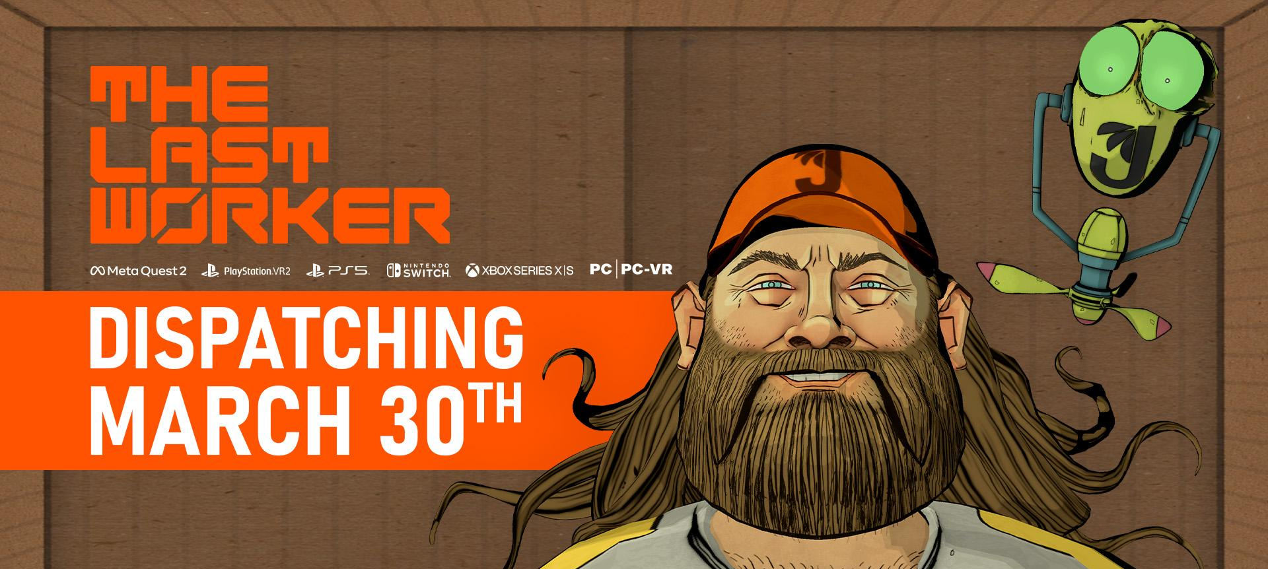
The Last Worker is Primed for Delivery on March 30th 2023
Pre-orders and Wishlists now Available on PSVR2, PS5, Nintendo Switch and PC, Ahead of Multi Format Release also on Meta Quest 2 and Xbox Series S|X
Watford, UK, March 2nd, 2023 - Publisher Wired Productions, Writer/Director Jörg Tittel, and pioneering independent games studio Wolf & Wood, can confirm that first-person narrative adventure, The Last Worker, will be ready for delivery this month, March 30th. Available to purchase from €19.99 / £15.99 / $19.99. The Last Worker will be released on Meta Quest 2, PSVR2, PS5, Nintendo Switch, Xbox Series S|X and PCVR alongside a PC release on Steam, Epic Games Store, GOG and Utomik. Players can Pre-order on Nintendo Switch, and wishlist on PlayStation and Steam today, or find a retailer via the Wired Website.
The brand new ‘Don’t be a robot’ trailer invites you to join Kurt (Ólafur Darri Ólafsson) and Skew (Jason Isaacs) on shift as they dispatch dreams, while gaining insight into the co-dependent nature of their relationship - regardless of how (jail) broken Skew can get.
Watch Don't be a Robot | Release Date Trailer:
https://youtu.be/bm8GSmtFp6M
The Last Worker is a first-person narrative adventure centered around humanity’s struggle in an increasingly automated world, where humans are being replaced by robots. Created from the ground up to deliver both VR and flat-packed experiences, the game combines a hand-crafted art style created in collaboration with comics legend Mick McMahon (Judge Dredd, 2000 AD) and unique, immersive gameplay mechanics, seamlessly interwoven into a narrative game like no other.
The Last Worker delivers an emotional, thought-provoking story filled with rich characters performed by an all-star cast including Jason Isaacs (Harry Potter, Star Trek Discovery), Ólafur Darri Ólafsson (The Meg, True Detective), Clare-Hope Ashitey (Riviera, Children of Men), David Hewlett (The Shape of Water, Oddworld New’n’Tasty), Zelda Williams (The Legend of Korra) and Tommie Earl Jenkins (Death Stranding, Wednesday). The Last Worker is scored by Oliver Kraus, known for his collaborations with the likes of Adele, Sia, and Florence and the Machine.
"Just as the pandemic has made us all dependent on home deliveries, it took us a whole pandemic to deliver this game." said Writer, Director Jörg Tittel, whose company, Oiffy, is also producing the game. "We've often felt like Kurt, overworked, lonely and tired, with Skew reminding us that there will be fun and light at the end of this fulfilment center. I hope you all make The Last Worker your next instant purchase."
"At the heart of it is the story of Kurt, someone who puts their job before everything else and we pick up as he, rather uncooperatively, is thrust into a scenario that requires him to take back control. From satisfying the daily quota, to moments of satire, stealth and a shootout, The Last Worker is always moving in a seamless flow of adventure and absurdist narrative." said Ryan Bousfield, Creative Director at Wolf & Wood.
Players can also support capitalism by ordering the Jüngle Pronto physical edition. Packed with a reversible sleeve, Jüngle stickers and a double-sided poster, fans can grab a copy from the likes of Amazon (not awkward) at just £19.99 / $24.99 / €24.99 for the PlayStation 5 version and £24.99 / $29.99 / €29.99 for Nintendo Switch.
For more information, search @TheLastWorker on Twitter, Instagram or google.
Download all assets via: https://media.wiredproductions.com/
SKEW, a The Last Worker spin-off for the Playdate handheld game system starring the Jason Isaacs voiced co-bot, is also coming out in March 2023. Developed by game dev legend Frédérick Raynal (Alone in the Dark, Little Big Adventure), SKEW was named one of IGN's 10 Best Playdate Games.

PR Contacts:

Renaissance PR
Stefano Petrullo – Renaissance PR
stefano@renaissancepr.biz
+44 (0) 7828 692 315

Greg Jones – Renaissance PR
greg@renaissancepr.biz
+44 (0) 7867 788 079

Wired Productions
Anastasia Denisova
press@wiredproductions.com
###
About Wired Productions
Wired Productions is an independent video games publisher based in Watford, UK. Wired has produced and published award-winning titles across all major platforms and its games are curated to deliver on its mantra: ‘Driven by Passion.’ Bringing games to market in both physical and digital media, recent notable launches include Arcade Paradise, Martha Is Dead, The Falconeer, Deliver Us The Moon. Upcoming titles include Tin Hearts, Tiny Troopers: Global Ops, The Last Worker, Gori: Cuddly Carnage, Hotel Architect and Bulwark: Falconeer Chronicles.

Find @WiredP on YouTube, Discord, Twitter or search Wired Productions on google.

About Jörg Tittel / Oiffy
Jörg Tittel is a London based writer, director and producer. In 2011, he founded Oiffy with director/writer Alex Helfrecht and producer Philip Munger. Their debut feature was THE WHITE KING starring Jonathan Pryce and Fiona Shaw, which Jörg co-directed with Alex. Jörg’s satirical graphic novel RICKY ROUSE HAS A GUN was a Boston Globe Book of the Year. Oiffy’s next feature film is the painted-animated musical adventure drama A WINTER’S JOURNEY starring John Malkovich and Jason Isaacs, based on Franz Schubert’s “Winterreise'' and animated by the artists behind the Oscar nominated LOVING VINCENT. Distributed by Sony Pictures Classics, it is the first feature film to be made with the help of PlayStation and Media Molecule’s BAFTA winning Dreams™. Together with Frédérick Raynal (creator of Alone in the Dark), he’s been working on SKEW, a spin-off of The Last Worker for Playdate coming in early 2023. Search @NewJorg on Twitter.
About Wolf & Wood
Wolf & Wood are an independent games studio based in the North East of England. The small but multi-talented team have written, designed and developed a number of first-person narrative titles including The Exorcist: Legion VR, which expands on the Oscar-winning horror franchise created by William Peter Blatty and have self-published their own award-winning IP, A Chair in a Room: Greenwater and the rock’n’roll riot, Hotel R’n’R. Search WolfandWood on Twitter or Google for more.

