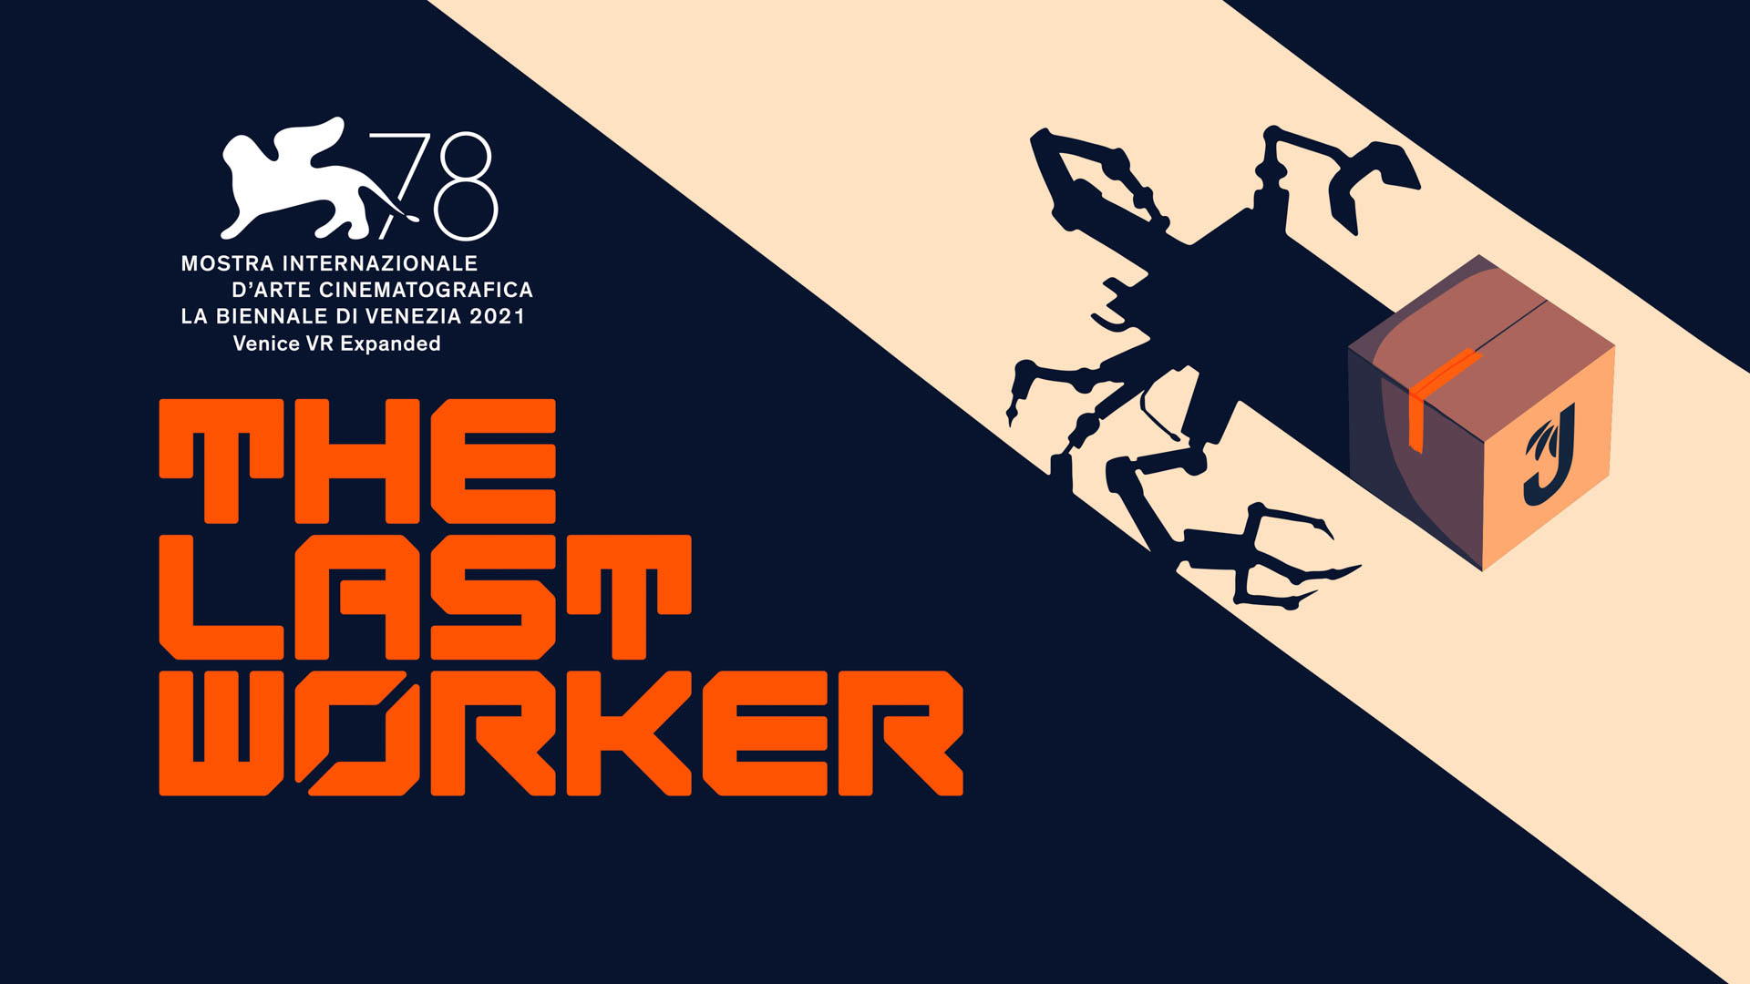

Zelda Williams and Tommie Earl Jenkins join star-studded narrative adventure The Last Worker

Stunning new trailer showcases thought-provoking narrative; first consumer hands-on at PAX East

Watford, UK – 19th April 2022 – Publisher Wired Productions, Writer / Director Jörg Tittel and pioneering games studio Wolf & Wood are today thrilled to announce that Zelda Williams (The Legend of Korra) and Tommie Earl Jenkins (Death Stranding) have joined the cast of the upcoming narrative adventure The Last Worker. A brand-new trailer, featuring Zelda, as well as existing cast members David Hewlett, Jason Isaacs and Ólafur Darri Ólafsson, unpackages the dystopian, thought-provoking world of the game and showcases its stunning hand-crafted visuals.

Watch the “End-Stage Capitalism” Trailer:
https://youtu.be/oOQpVmdyLpQ

Visitors to PAX East, (Boston, MA) this weekend can get the world’s first hands-on with The Last Worker, by swinging by the Wired Productions booth at 14030, located at the heart of the show floor.

Zelda Williams and Tommie Earl Jenkins join a star-studded cast alongside Jason Isaacs (The Death of Stalin), Ólafur Darri Ólafsson (The Deep), Clare-Hope Ashitey (Children of Men) and David Hewlett (The Shape of Water).

The Last Worker is a first person narrative adventure centred around our struggle in an increasingly automated world. Combining a hand crafted art style with uniquely immersive gameplay mechanics in an epic setting, The Last Worker delivers an emotional, thought provoking and comedic story packaged with rich characters performed by an all-star cast.

“Who would’ve thought a casual conversation on Twitter in the middle of a global pandemic would somehow lead us here?”, said Zelda Williams. “I’ll be forever grateful that Jörg saw fit to send another battle-weary warrior woman my way, and it was a joy to lend her my voice.”

“Working with such a stellar cast would be miraculous enough on a major feature film or series”, said Writer, Director Jörg Tittel, whose company, Oiffy, is producing the game. “But to have such world class actors lend their talent to an indie game must make me the luckiest man alive. But ultimately this game has been an equaliser, with every team member pouring heart and soul into every minute detail. No matter how dystopian they want to make the real world, ours at least will be full of colour and crafted with love.”

“The anticipation of seeing the first public demo of the game is really building in the studio” , said Ryan Bousfield, Creative Director of Wolf & Wood, “As a collective, we’ve all had a part in shaping the stylised world and unique characters of The Last Worker, but now, to have such beautiful performances from an amazing cast to top it all off, fills us with confidence for the public response!”

“The Last Worker continues to be a thrilling project to work on with the groundbreaking storytelling from Jörg, and the technical genius of Wolf & Wood,” said Neil Broadhead, Head of Marketing, Wired Productions. “With the addition of Zelda Williams and Tommie Earl Jenkins to the all-star cast, we are so excited for visitors at PAX to get their hands on The Last Worker for the very first time!”

The Last Worker will be released in 2022 on Steam, Epic Games Store, GOG, Nintendo Switch, PlayStation 5, Xbox Series X|S and Meta Quest 2.

For more information, check out the latest news and wishlist via Steam, visit the official website for The Last Worker or follow on Twitter or Instagram.

###

PR Contacts
Wired Productions
Tegan Kenney | press@wiredproductions.com

Dead Good PR for Wired Productions
wired@deadgoodmedia.com

About Wired Productions
Wired Productions is an independent video games publisher based in Watford, UK. Wired has produced and published award-winning titles across all major platforms and its games are curated to deliver on its mantra: ‘Driven by Passion.’ Bringing games to market in both physical and digital media, notable launches to date include Martha Is Dead, The Falconeer, Those Who Remain, Deliver Us The Moon, Close to the Sun, GRIP: Combat Racing, Victor Vran: Overkill Edition, Max: The Curse of Brotherhood and The Town of Light. Recently, Wired Productions announced its upcoming slate of titles during Wired Direct. Upcoming titles include Lumote, Arcade Paradise, Tin Hearts, Tiny Troopers:Global Ops and The Last Worker.
Join the Wired community via: Wired Live | Twitter | Discord | YouTube | Twitch

About Jörg Tittel / Oiffy
Jörg Tittel is a London based writer, director and producer. In 2011, he founded Oiffy with director/writer Alex Helfrecht and producer Philip Munger. Their debut feature THE WHITE KING starring Jonathan Pryce and Fiona Shaw, which Jörg co-directed with Alex, premiered at the 2016 Edinburgh International Film Festival, where it was nominated for the Michael Powell Award for Best British Feature. Filming in summer 2022 is their next feature, the painted animated live music adventure drama A WINTER’S JOURNEY, Helfrecht’s adaptation of Franz Schubert’s “Winterreise” animated by the artists behind the Oscar nominated LOVING VINCENT. Distributed by Sony Pictures Classics, it is the first feature film to be made with the help of PlayStation and Media Molecule’s BAFTA winning Dreams™. Oiffy.com

About Wolf & Wood
Wolf & Wood are an independent games studio based in the North East of England. The small but multi-talented team have written, designed and developed a number of first-person narrative titles including The Exorcist: Legion VR, which expands on the Oscar-winning horror franchise created by William Peter Blatty and their own award-winning IP, A Chair in a Room: Greenwater and the rock’n’roll riot, Hotel R’n’R. Wolfandwood.co

