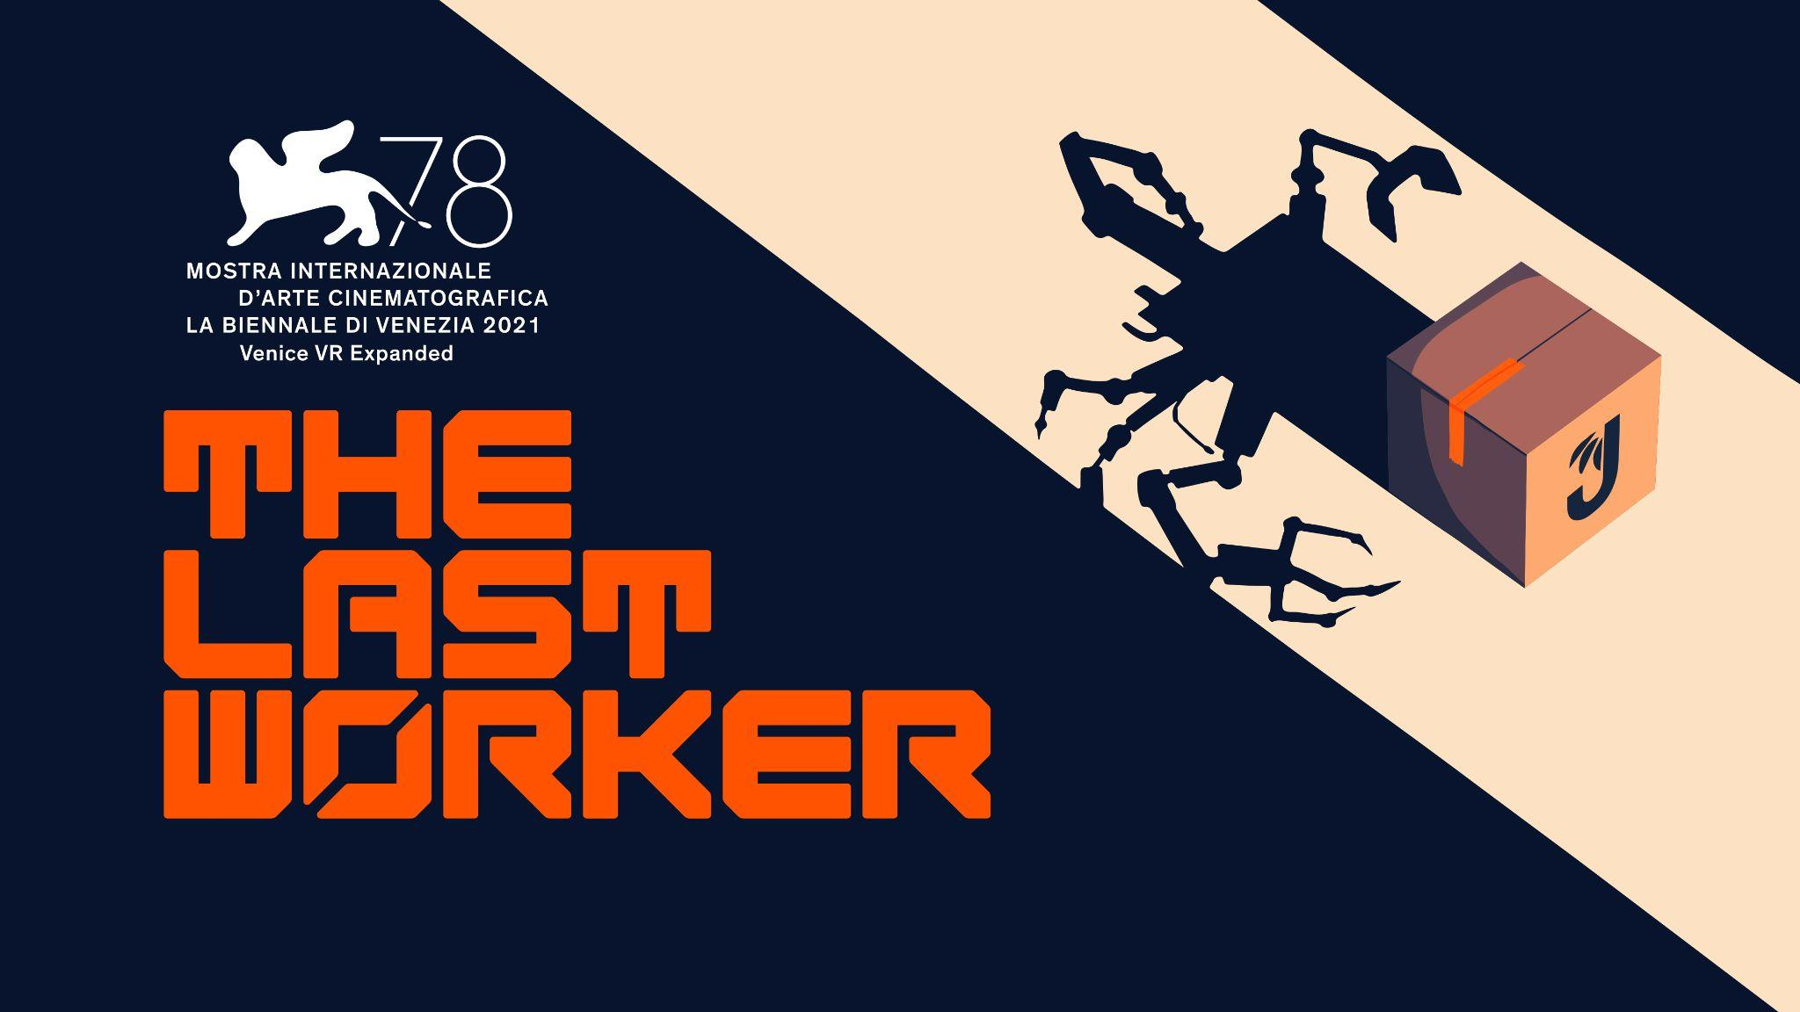

Enter the Automated Jüngle of The Last Worker

The Last Worker Dispatching for PC, October 19th 2022

Watford, UK, 26th August, 2022 - Publisher Wired Productions, Writer/Director Jörg Tittel and pioneering independent games studio Wolf & Wood are thrilled to announce that first-person narrative adventure The Last Worker will come to PC first, launching on Steam, Epic Games Store and GOG on October 19th, 2022.

Set in Jüngle Fulfillment Center 1, the largest retail facility on Earth, The Last Worker is a first-person narrative adventure centered around humanity’s struggle in an increasingly automated world, where humans are being replaced by robots. The game combines a hand-crafted art style created in collaboration with comics legend Mick McMahon (Judge Dredd, 2000 AD) and unique, immersive gameplay mechanics, seamlessly interwoven into a narrative game like no other.

The Last Worker delivers an emotional, thought-provoking story filled with rich characters performed by an all-star cast including Jason Isaacs (Harry Potter, Star Trek Discovery), Ólafur Darri Ólafsson (The Meg, True Detective), Clare-Hope Ashitey (Children of Men), David Hewlett (The Shape of Water), Zelda Williams (The Legend of Korra) and Tommie Earl Jenkins (Death Stranding). The Last Worker is scored by Oliver Kraus, known for his collaborations with the likes of Adele, Sia, and Florence and the Machine.

Watch The Last Worker PC Release Date Trailer Here:
https://youtu.be/b5VPo2rqS2M

The official PC release date trailer gives insight into the lonely, oppressive, yet strangely beautiful setting of JFC-1. Featuring gameplay footage of our protagonist, Kurt, aboard his corporate issued JünglePod set against a ‘motivational’ speech by CEO Josef Jüngle reminding players that customer satisfaction is what holds the Jüngle Family together, whatever the cost.

“I never thought I’d turn into Kurt, but after spending over two years mostly working from home, I feel his pain. Thankfully The Last Worker is much more fun than our real-life dystopia”, said Writer, Director Jörg Tittel, whose company, Oiffy, is producing the game.

“It is a unique setting, with a colourful mix of retro-futurism but it is also a working facility, the WorkerBots are carrying out their day-to-day dispatches or patrolling the No-Go-Zones. The team have come up with all kinds of creative solutions to bring this hand-drawn world to life.”, said Ryan Bousfield, Creative Director of Wolf & Wood.

“With Christmas being such a big season for certain retailers, we wanted people to have the opportunity to truly digest the important message conveyed in The Last Worker well ahead of time.” Said Leo Zullo, Managing Director, Wired Productions. “Get ready to fight the establishment!”

The Last Worker will be released on 19th October 2022 for Steam, Epic Games Store and GOG. The game will also release on consoles and VR at a later date.

Join the Official Discord today. Home to dedicated content, the community will have the opportunity to speak directly with Writer/Director Jörg Tittel and the multi-talented development team at Wolf & Wood.

For more information, check out the latest news and Wishlist via Steam, visit the official website or follow on Twitter or Instagram.

Download all assets via: https://media.wiredproductions.com/games/the-last-worker/

PR Contacts:
Renaissance PR
Stefano Petrullo – Renaissance PR
stefano@renaissancepr.biz
+44 (0) 7828 692 315
Greg Jones – Renaissance PR
greg@renaissancepr.biz
+44 (0) 7867 788 079
Gabrielle Hibberd – Renaissance PR
gabrielle@renaissancepr.biz
+44 (0) 7429 046 311
Wired Productions
Tegan Kenney & Anastasia Denisova | press@wiredproductions.com
###

About Wired Productions
Wired Productions is an independent video games publisher based in Watford, UK. Wired has produced and published award-winning titles across all major platforms and its games are curated to deliver on its mantra: ‘Driven by Passion.’ Bringing games to market in both physical and digital media, notable launches to date include Arcade Paradise, Lumote: The Mastermote Chronicles, Martha Is Dead, The Falconeer, Those Who Remain, Deliver Us The Moon, Close to the Sun, GRIP: Combat Racing, Victor Vran: Overkill Edition, Max: The Curse of Brotherhood and The Town of Light. Upcoming titles include Gori: Cuddly Carnage, Tin Hearts, Tiny Troopers: Global Ops and The Last Worker.
Join the Wired community via: Wired Live | Twitter | Discord | YouTube | Twitch
About Jörg Tittel / Oiffy

Jörg Tittel is a London based writer, director and producer. In 2011, he founded Oiffy with director/writer Alex Helfrecht and producer Philip Munger. Their debut feature THE WHITE KING starring Jonathan Pryce and Fiona Shaw, which Jörg co-directed with Alex, premiered at the 2016 Edinburgh International Film Festival, where it was nominated for the Michael Powell Award for Best British Feature. Jörg’s satirical graphic novel “Ricky Rouse Has a Gun” was a Boston Globe Book of the Year. Oiffy’s next feature film is the painted-animated musical adventure drama A WINTER’S JOURNEY starring John Malkovich and Jason Isaacs, based on Franz Schubert’s “Winterreise'' and animated by the artists behind the Oscar nominated LOVING VINCENT. Distributed by Sony Pictures Classics, it is the first feature film to be made with the help of PlayStation and Media Molecule’s BAFTA winning Dreams™. Oiffy.com

About Wolf & Wood

Wolf & Wood are an independent games studio based in the North East of England. The small but multi-talented team have written, designed and developed a number of first-person narrative titles including The Exorcist: Legion VR, which expands on the Oscar-winning horror franchise created by William Peter Blatty and their own award-winning IP, A Chair in a Room: Greenwater and the rock’n’roll riot, Hotel R’n’R. Wolfandwood.co

