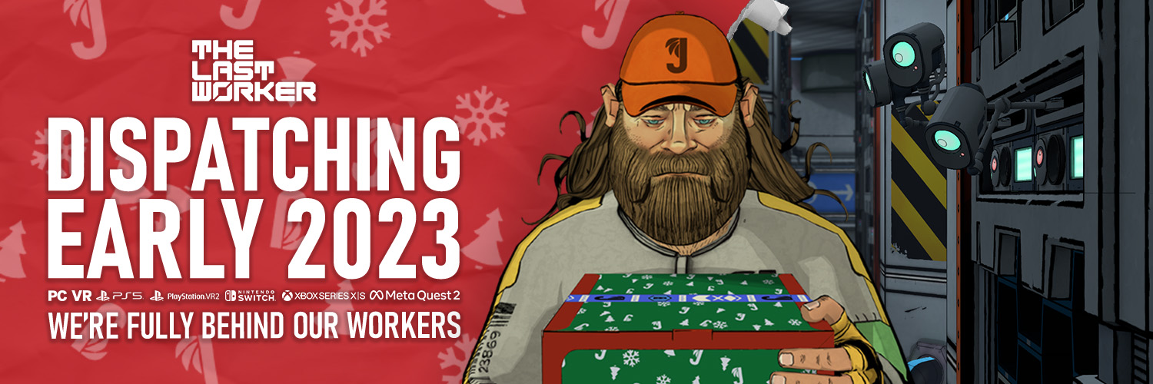
It’s Jüngle All the Way This Christmas… or is it!?
Big Bearded Guy Dispatching Presents on a Flying Scooter Delivers PSVR2 News along with Jüngle Pronto Physical Edition

Watford, UK, 7th December, 2022 - Publisher Wired Productions, Writer/Director Jörg Tittel and pioneering independent games studio Wolf & Wood are thrilled to unveil a brand-new Christmas advert from the Jüngle Corporation, the largest online retailer dominating the increasingly automated world of The Last Worker. In addition, The Last Worker is now confirmed for PlayStation VR2, alongside Steam, Epic Games Store, GOG, Nintendo Switch, PlayStation 5, Xbox Series X|S and Meta Quest 2 in 2023. Wishlist on Steam at https://store.steampowered.com/app/1579280 and wishlist on PS5 (and PSVR2) right now via https://store.playstation.com/en-gb/concept/10002752! A brand new Jüngle Pronto Physical Edition has also been unveiled as coming soon.

Watch the Christmas Trailer Here: https://youtu.be/8CzFqnZwXiE

The Last Worker is a first-person narrative adventure centered around humanity’s struggle in an increasingly automated world, where humans are being replaced by robots. The game combines a hand-crafted art style created in collaboration with comics legend Mick McMahon (Judge Dredd, 2000 AD) and unique, immersive gameplay mechanics, seamlessly interwoven into a narrative game like no other. The latest trailer for The Last Worker, in true Christmas spirit, takes viewers through the Jüngle Fulfillment Centre (JFC-1) during the most fulfilling time of the year for millions of warehouse workers.

Publisher Wired Productions confirmed that in addition to the already announced formats, The Last Worker will be available as a PS5 game and a PSVR2 title, but players won’t need to pay for an upgrade. Players who buy the game on PlayStation 5 will receive both versions – and the save files and progress carry over between them – meaning if wannabe dispatchers spend the morning fully immersed in the PSVR2 world of JFC-1, but want to quickly get a shift in later without setting up your VR kit, they can carry on playing on their TV in true flat-packed mode.
In addition, Wired Productions are pleased to announce the Jüngle Pronto physical edition of The Last Worker. Available later in 2023 the Pronto Edition features a reversible sleeve, Jüngle stickers and a double-sided poster. Players can register their interest via https://shop.wiredproductions.com/collections/the-last-worker.

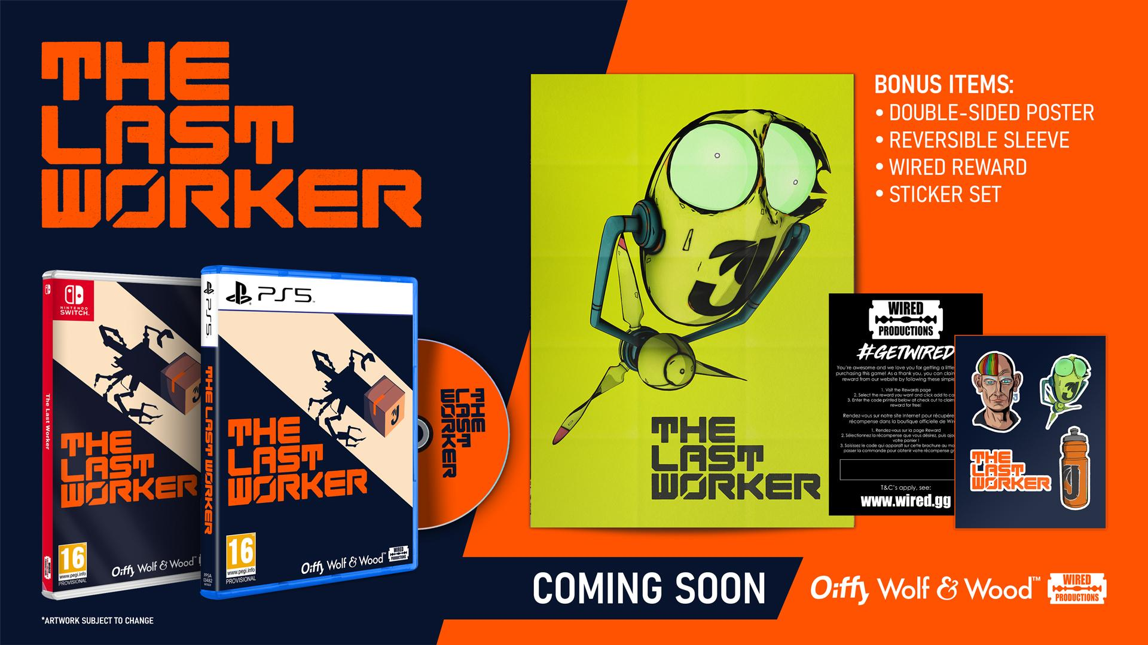

The Last Worker delivers an emotional, thought-provoking story filled with rich characters performed by an all-star cast including Jason Isaacs (Harry Potter, Star Trek Discovery), Ólafur Darri Ólafsson (The Meg, True Detective), Clare-Hope Ashitey (Children of Men), David Hewlett (The Shape of Water, Oddworld New’n’Tasty), Zelda Williams (The Legend of Korra) and Tommie Earl Jenkins (Death Stranding, Wednesday). The Last Worker is scored by Oliver Kraus, known for his collaborations with the likes of Adele, Sia, and Florence and the Machine.

“Like his real world counterparts, Mr. Jüngle has a lot to be merry about,” said Writer, Director Jörg Tittel, whose company, Oiffy, is producing the game. “If only the fact that he’s raking in billions while hordes of increasingly dehumanized workers struggle to get that superhero themed electric toothbrush head to you on time. Naturally we couldn’t let him get all the $$$, so we’ve been crafting this cynical product for you to consume. Happy Capitalist Ho Ho Horror!”

"You embody Kurt, a big man, with a big beard, who delivers 'presents' on a flying scooter." said Ryan Bousfield, Creative Director at Wolf & Wood, "Although you have robots instead of reindeer, it's testament to the immersive power of VR that such an unusual and stylised world still feels 'real' when you're in there!"

The Last Worker will be released in 2023 on Steam, Epic Games Store, GOG, Nintendo Switch, PlayStation 5, PSVR 2, Xbox Series S|X and Meta Quest 2. Players can Wishlist on Steam and PlayStation today.

Join the Official Discord today. Home to dedicated content, the community will have the opportunity to speak directly with Writer/Director Jörg Tittel and the multi-talented development team at Wolf & Wood. For more information, visit the official website for The Last Worker or follow on Twitter or Instagram.

PR Contacts:

Renaissance PR

Stefano Petrullo – Renaissance PR
stefano@renaissancepr.biz
+44 (0) 7828 692 315

Greg Jones – Renaissance PR
greg@renaissancepr.biz
+44 (0) 7867 788 079

Wired Productions
Tegan Kenney & Anastasia Denisova
press@wiredproductions.com

###

About Wired Productions
Wired Productions is an independent video games publisher based in Watford, UK. Wired has produced and published award-winning titles across all major platforms and its games are curated to deliver on its mantra: ‘Driven by Passion.’ Bringing games to market in both physical and digital media, recent notable launches include Arcade Paradise, Martha Is Dead, The Falconeer and Deliver Us The Moon. Upcoming titles include Tin Hearts, Tiny Troopers: Global Ops, The Last Worker, Gori: Cuddly Carnage, Hotel Architect and Bulwark: Falconeer Chronicles.
For a deeper dive into the Wired world, watch Wired Unplugged: http://wired.gg/wiredlive
And for those who love music and video games, head to Black Razor: https://blackrazorrecords.bandcamp.com/album/arcade-paradise-ep
Join the Wired community via: Wired Live | Twitter | Discord | YouTube | Twitch
About Jörg Tittel / Oiffy
Jörg Tittel is a London based writer, director and producer. In 2011, he founded Oiffy with director/writer Alex Helfrecht and producer Philip Munger. Their debut feature was THE WHITE KING starring Jonathan Pryce and Fiona Shaw, which Jörg co-directed with Alex. Jörg’s satirical graphic novel RICKY ROUSE HAS A GUN was a Boston Globe Book of the Year. Oiffy’s next feature film is the painted-animated musical adventure drama A WINTER’S JOURNEY starring John Malkovich and Jason Isaacs, based on Franz Schubert’s “Winterreise” and animated by the artists behind the Oscar nominated LOVING VINCENT. Distributed by Sony Pictures Classics, it is the first feature film to be made with the help of PlayStation and Media Molecule’s BAFTA winning Dreams™. Together with Frédérick Raynal (creator of Alone in the Dark), he’s been working on SKEW, a spin-off of The Last Worker for Playdate coming in early 2023. Follow Jörg on Twitter.
About Wolf & Wood
Wolf & Wood are an independent games studio based in the North East of England. The small but multi-talented team have written, designed and developed a number of first-person narrative titles including The Exorcist: Legion VR, which expands on the Oscar-winning horror franchise created by William Peter Blatty and have self-published their own award-winning IP, A Chair in a Room: Greenwater and the rock’n’roll riot, Hotel R’n’R. Read more at Wolfandwood.co or follow on Twitter.

