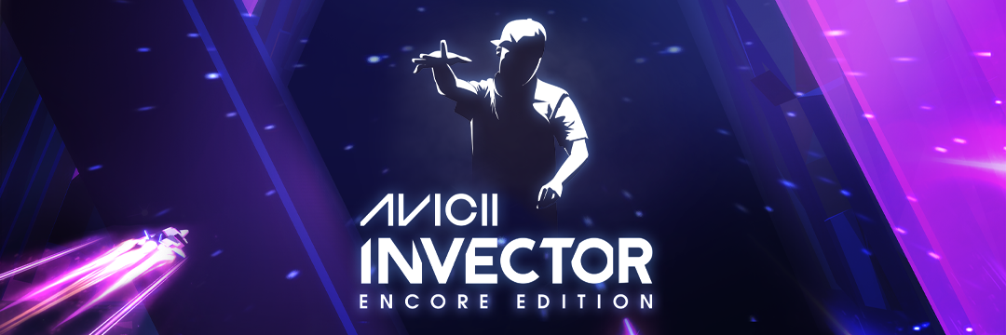
The legacy of Tim Bergling Continues with AVICII Invector: Encore Edition Coming to Meta Quest 2 on 27 January 2022
Hello There Games and Wired Productions to Finish What Tim Started by Bringing AVICII Invector to VR, for the Ultimate Way to Experience AVICII’s Music.
Watford, UK – January 6th, 2022 – Global video games publishing label Wired Productions and award-winning indie studio Hello There Games are proud to announce that 2022 will start in pulse-pounding fashion as AVICII Invector: Encore Edition comes to Meta Quest 2 on January 27, 2022. In loving memory of Swedish DJ Tim Bergling, most famously known by his professional name, AVICII, Hello There Games and Tim’s father, Klas Bergling, continue Tim’s vision of bringing new ways to experience his music, with AVICII Invector: Encore Edition. Featuring 35 chart topping tracks such as Peace of Mind, Freak and S.O.S, AVICII Invector brings the futuristic rhythm action gameplay into a VR version for Meta Quest 2 which is available to Wishlist now.
Watch AVICII Invector: Encore Edition Reveal Trailer: https://youtu.be/4atsA1QGE5o
All music royalties from each copy of the game sold will go to the Tim Bergling Foundation, which advocates for the recognition of suicide as a global health emergency and actively works to remove the stigma attached to suicide and mental health issues.
“When Tim and I first started talking about Invector, he was actually sent an early prototype VR headset. He was fascinated by the technology and the opportunities it created.” Said Oskar Eklund, the CEO of Hello There Games, “Working with Tim’s father, Klas, to finish this project has been an emotional process for the whole team. We still grieve for Tim, but we came together knowing this was a project he was very passionate about and hope his fans can continue to celebrate and remember AVICII for the light that he was.”
“At Wired, we are all about celebrating the art, music, and developers behind each release. AVICII Invector, in many ways, is our perfect match.” Said Leo Zullo, Managing Director, Wired Productions. “Bringing AVICII Invector to VR has been a labour of love, one that will immerse fans and Meta Quest gamers alike in an unforgettable virtual reality experience. An experience which, I hope, will continue to celebrate Tim’s music and legacy for years to come.”
AVICII Invector: Encore Edition Features:
- 35 hit anthems from the phenomenal talent of late superstar AVICII.
- SEVEN mesmerising worlds wrapped in a magnificent musical experience viewable in VR.
- Turn up the volume and set yourself a challenge across FOUR complexity levels.
- Lay down your high score and rise up the Global Leaderboards.
- Explore a pure-hearted narrative journey set against the globally celebrated works of AVICII.
In addition, the release of AVICII Invector: Encore Edition on Meta Quest 2 see’s the start of a partnership between Wired Productions and Meta to bring new and existing IPs to the VR platform, with The Last Worker and Tin Hearts also coming to Meta Quest 2 in 2022.
AVICII Invector: Encore Edition launches on Meta Quest 2 on January 27, 2022 and is available to Wishlist now via Meta Quest.
For more information, visit https://wiredproductions.com/games/
###
About Wired Productions
Wired Productions is an independent video games publisher based in Watford, UK. Wired has produced and published award-winning titles across all major platforms and its games are curated to deliver on its mantra: ‘Driven by Passion.’ Bringing games to market in both physical and digital media, notable launches to date include The Falconeer, Those Who Remain, Deliver Us The Moon, Close to the Sun, GRIP: Combat Racing, Victor Vran: Overkill Edition, Max: The Curse of Brotherhood and The Town of Light. Recently, Wired Productions announced its upcoming slate of titles during Wired Direct. Upcoming titles include, Lumote, Arcade Paradise, Martha Is Dead, Tin Hearts, Tiny Troopers: Global Ops and The Last Worker.
Join the Wired community via: Wired Live| Twitter | Discord | YouTube |Twitch
About Hello There Games
Hello There Games is an independent game studio, founded in 2009 in Gothenburg, Sweden. Hello There, as the studio was called back then, quickly released a series of successful games for various clients, including global brands and Swedish organisations. A few years, awards, and many various games later, Hello There had extended their partnerships into the entertainment business. Working with (the now late) superstar AVICII.
Join The Hello There Games community: Discord | Instagram | TikTok | Twitter | YouTube |
Contact
Wired Productions
Tegan Kenney | press@wiredproductions.com
Dead Good PR for Wired Productions | wired@deadgoodmedia.com

