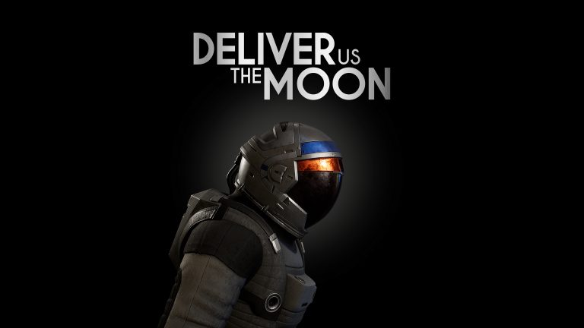

‘We have a liftoff!’ Deliver Us The Moon Out Now for PlayStation 5 and Xbox Series X|S

Physical Edition Available Now Exclusively for PlayStation 5; Free Digital Upgrade available for existing owners

Watford, UK, 23 June, 2022 - Publisher Wired Productions and acclaimed Dutch game studio KeokeN interactive are proud to announce that the award-winning sci-fi thriller, Deliver Us The Moon launches today for PlayStation 5 and Xbox Series X|S, priced at $24.99 / €24.99 / £19.99. Existing owners on PlayStation 4 and Xbox One can upgrade at no additional cost. PlayStation 5 owners can pick up the physical edition of the game via the Wired Productions store for £19.99, through Limited Run Games for US customers at $24.99, or European retailers at €24.99.

The astronomical launch trailer showcases everything the definitive version of Deliver Us The Moon has to offer with fully remastered out-of-this-world 4K visuals and stunning ray-traced shadows and reflections. The next-gen features add infinite new levels of immersion to the science-fiction epic.

Watch the Deliver Us The Moon Next-Gen Launch Trailer:
https://youtu.be/KAFMUTc-iVo

Deliver Us The Moon is a sci-fi thriller set in an apocalyptic near future, where Earth’s natural resources are depleted. A lunar colony providing a vital supply of energy has gone silent. A lone astronaut is sent to the moon on a critical mission to save humanity from extinction. Will you save mankind or be forgotten in the dark abyss of Space?
Features
- Tackle real world issues
- 1st and 3rd Person perspective, including driving numerous vehicles
- Vast, open moonscape to explore and discover
- Suspense driven action
- Anti-gravity gameplay sequences
- Clever, challenging puzzles
- Haunting, orchestral soundtrack
- Powered by Unreal® Engine 4
Next Gen Upgrades
- Fully remastered in 4K with ray-traced shadows and reflections
- Jump into the action quicker with faster loading times
- PlayStation 4 and Xbox One owners upgrade to Next Gen version for free
The Deliver Us The Moon PlayStation 4 Collector’s Edition will also receive a free digital PlayStation 5 Upgrade to the Physical Deluxe Edition copy of the game. Available via the Wired Productions Store, the must-have Collector’s Edition includes the award-winning original soundtrack on 12” Double Vinyl, an Exclusive and limited Moonman “The Blackout” Comic Book”, a stellar hardback Deliver Us The Moon Artbook, and more.
Deliver Us The Moon launches today on PlayStation 5 and Xbox Series X|S, priced at $24.99 / €24.99 / £19.99. A physical edition is available now on PlayStation 5, which includes a double-sided folded poster, a reversible sleeve, a stellar set of stickers, plus a digital download of the Deliver Us The Moon EP via the Wired Productions Store or find a retailer in Wired’s Where to Buy section.

For more information, follow Wired Productions on Twitter, join the official Discord or visit: https://www.deliverusthemoon.com/

Media Enquiries:
Wired Productions
Tegan Kenney | press@wiredproductions.com
###
About Wired Productions
Wired Productions is an independent video games publisher based in Watford, UK. Wired has produced and published award-winning titles across all major platforms and its games are curated to deliver on its mantra: ‘Driven by Passion.’ Bringing games to market in both physical and digital media, notable launches to date include Lumote: The Mastermote Chronicles, Martha Is Dead, The Falconeer, Those Who Remain, Deliver Us The Moon, Close to the Sun, GRIP: Combat Racing, Victor Vran: Overkill Edition, Max: The Curse of Brotherhood and The Town of Light. Recently, Wired Productions announced its upcoming slate of titles during Wired Direct. Upcoming titles include Arcade Paradise, Tin Hearts, Tiny Troopers: Global Ops, The Last Worker and Gori: Cuddly Carnage.
Join the Wired community via: Wired Live | Twitter | Discord | YouTube | Twitch
About KeokeN Interactive
KeokeN Interactive is a Dutch independent game developer founded in 2013 by two brothers Koen and Paul Deetman. Envisioning the games industry as a platform to go beyond traditional gaming and create immersive experiences, KeokeN Interactive aim to develop rich and believable worlds that will make you forget your surroundings and push the boundaries of your reality. KeokeN Interactive’s first game was the well-received and award-winning Deliver Us The Moon.

