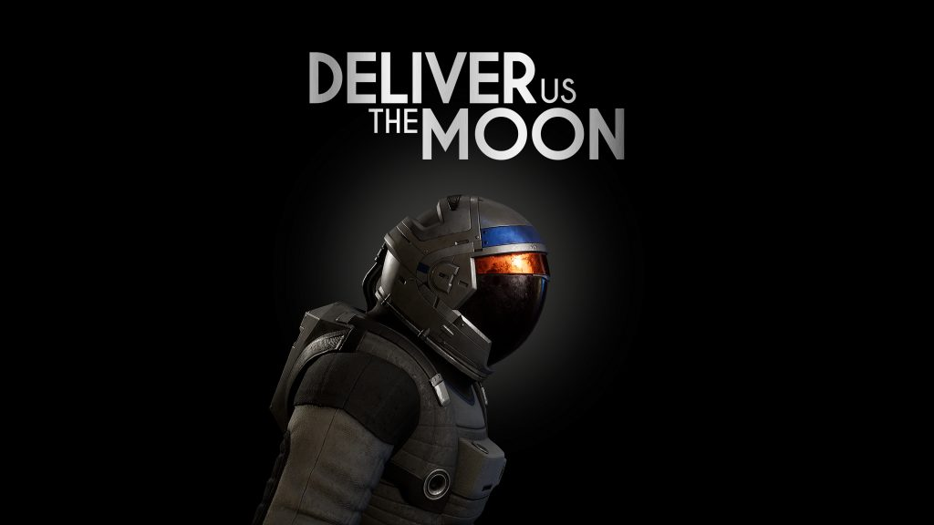
One (more) Small Step for Deliver Us The Moon Next-Gen
Sci-Fi Thriller confirms 23rd June release
Watford, UK - 12 May, 2022 - Publisher Wired productions and acclaimed Dutch game studio KeokeN Interactive today announce that the award-winning sci-fi thriller Deliver Us The Moon will now launch on 23rd June, 2022 for PlayStation 5 and Xbox Series X|S. The astronomical project requires additional development time to prepare the definitive version of the game, allowing for a final polish before we prepare for lift off. The title also sees a physical launch on PlayStation 5, available directly via the Wired store in addition to partners globally.
Featuring fully remastered 4K visuals, celestial ray-traced shadows and reflections, as well as next-gen features, Deliver Us The Moon next-gen adds cosmic proportions of immersion to the sci-fi epic.
Watch the Release Date Announcement Trailer:
https://youtu.be/uxIagn1tb9s
Deliver Us The Moon is a sci-fi thriller set in an apocalyptic near future, where Earth’s natural resources are depleted. A lunar colony providing a vital supply of energy has gone silent. A lone astronaut is sent to the moon on a critical mission to save humanity from extinction. Will you save mankind or be forgotten in the dark abyss of Space?
Deliver Us The Moon Features
- Tackle real world issues
- 1st and 3rd Person perspective, including driving numerous vehicles
- Vast, open moonscape to explore and discover
- Suspense driven action
- Anti-gravity gameplay sequences
- Clever, challenging puzzles
- Haunting, orchestral soundtrack
- Powered by Unreal® Engine 4
Next Gen Upgrades
- Fully remastered in 4K with ray-traced shadows and reflections
- Jump into the action quicker with faster loading times
- Adaptive triggers and controller speakers (PlayStation 5)
- PlayStation 4 and Xbox One owners upgrade to Next Gen version for free
Deliver Us The Moon will launch on June 23rd 2022 for PlayStation 5 and Xbox Series X|S, priced at $24.99 / €24.99 / £19.99 with existing console owners receiving a free digital upgrade.
The PlayStation 5 exclusive physical edition features a double-sided folded poster, a reversible sleeve, a stellar set of stickers, plus a digital download of the Deliver Us The Moon EP. Gamers can register their interest via the Wired Productions store, or find a retailer via Wired’s Where to Buy section.
Deliver Us The Moon will also be launching on Stadia and Stadia Pro, Google’s cloud gaming platform that lets you instantly play video games on screens that you already own, in 2022.
Follow us on Twitter, join the official Discord or visit: https://www.deliverusthemoon.com/
Media Enquiries:
Wired Productions
Tegan Kenney | press@wiredproductions.com
Dead Good PR for Wired Productions
wired@deadgoodmedia.com
###
About Wired Productions
Wired Productions is an independent video games publisher based in Watford, UK. Wired has produced and published award-winning titles across all major platforms and its games are curated to deliver on its mantra: ‘Driven by Passion.’ Bringing games to market in both physical and digital media, notable launches to date include Lumote: The Mastermote Chronicles, Martha Is Dead, The Falconeer, Those Who Remain, Deliver Us The Moon, Close to the Sun, GRIP: Combat Racing, Victor Vran: Overkill Edition, Max: The Curse of Brotherhood and The Town of Light. Recently, Wired Productions announced its upcoming slate of titles during Wired Direct. Upcoming titles include Arcade Paradise, Tin Hearts, Tiny Troopers: Global Ops, The Last Worker and Gori: Cuddly Carnage.
Join the Wired community via: Wired Live | Twitter | Discord | YouTube | Twitch
About KeokeN Interactive
KeokeN Interactive is a Dutch independent game developer founded in 2013 by two brothers Koen and Paul Deetman. Envisioning the games industry as a platform to go beyond traditional gaming and create immersive experiences, KeokeN Interactive aim to develop rich and believable worlds that will make you forget your surroundings and push the boundaries of your reality. KeokeN Interactive’s first game was the well-received and award-winning Deliver Us The Moon.

