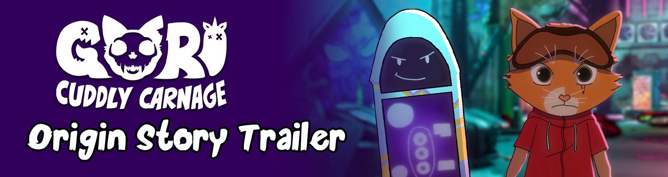

EPIC NEW ORIGINS TRAILER DROPS FOR THE HIGHLY ANTICIPATED VIDEO GAME; GORI: CUDDLY CARNAGE!

THE BRAND-NEW ANIMATED TRAILER ANSWERS THE QUESTION EVERYONE HAS BEEN ASKING; WHY IS A CAT ON A HOVERBOARD, KILLING UNICORNS?
Watford, UK – 24th October 2023: Publisher Wired Productions and developers Angry Demon Studio today finally peeled back the lid and dropped the meaty details surrounding the highly anticipated brutal hack ‘n’ slasher ‘Gori: Cuddly Carnage’. Revealed through the eyes and mouth of a synthetic hoverboard (and Gori’s best friend, F.R.A.N.K!), players are introduced to the back story and the complete lineup of reluctant heroes, tasked with saving the galaxy.
Watch the trailer now: https://youtu.be/mHebvvtft9s
Gori: Cuddly Carnage will launch in early 2024 on PC, Utomik, Nintendo Switch, PlayStation 4, PlayStation 5, Xbox Series X|S, and Xbox One. To wishlist the game, download wallpapers or sign up for breaking news, simply visit: gori.wtf.
Story Revealed
Humanity has been destroyed - and it's up to Gori, along with his deadly but wise-cracking sentient hoverboard, F.R.A.N.K, and morose A.I companion, CH1-P, to slay the evil Adorable Army with lethal combos.
Fuelled by insatiable demand, 'Cool-Toys Inc.' created 'Ultra Pets'. The ultimate companions that never hunger, never require bathroom breaks and are impervious to the ravages of time. Little did anyone expect the mutation that transformed these perfect pets into twisted toys straight from your nightmares, hell-bent on wiping out humanity.
Master explosive weaponry and devastating combos in an epic battle to prevent the Adorable Army from conquering the galaxy, and rescue Professor Y, their missing creator and only human who showed Gori and his friends love. Push your combat and platforming skills to the limits as you fight your way through twisted landscapes filled with environmental hazards, razor-sharp adult humour and a bone-crunching, pulse-pounding soundtrack.
Announced Key Features
- Play as a badass cat with a team of unlikely heroes
- Battle blood-thirsty hordes of mutated toys
- Explore multiple levels filled with lethal environmental hazards
- Master a devastating arsenal of explosives, razor-sharp weaponry and unlockable moves
- Use your extreme hoverboard parkour skills to explore every corner of the level for collectables
- Turn the town red with F.R.A.N.K’s blades as you slice and dice
- Skate and slay out to an original bone-crunching soundtrack

PR Contacts:
Anastasia Denisova
press@wiredproductions.com
###
About Wired Productions
Wired Productions is an independent video games publisher based in Watford, UK. Wired has produced and published award-winning titles across all major platforms and its games are curated to deliver on its mantra: ‘Driven by Passion.’ Bringing games to market in both physical and digital media, recent notable launches include Arcade Paradise, Martha Is Dead, The Last Worker and Tin Hearts.
Upcoming titles include Gori: Cuddly Carnage, Hotel Architect and Bulwark: Falconeer Chronicles
Find @WiredP on YouTube, Discord, and Twitter or search Wired Productions on Google.
About Angry Demon Studio
Angry Demon Studio is an independent game developer based in Skövde, Sweden, focused on creating high-quality, adrenaline-filled experiences and pushing the boundaries of what’s possible in small-scale game dev. Its debut title Unforgiving – a Northern Hymn was a hauntingly unforgettable slice of Nordic folk horror. The team explored these themes further with a striking vision of future viking terror in Apsulov: End of Gods, and is currently hard at work on the ultra-inventive, ultra-violent, ultra-cute skate-and-slasher Gori: Cuddly Carnage.
For more information, please follow ADS on Twitter or visit https://angrydemonstudio.com

