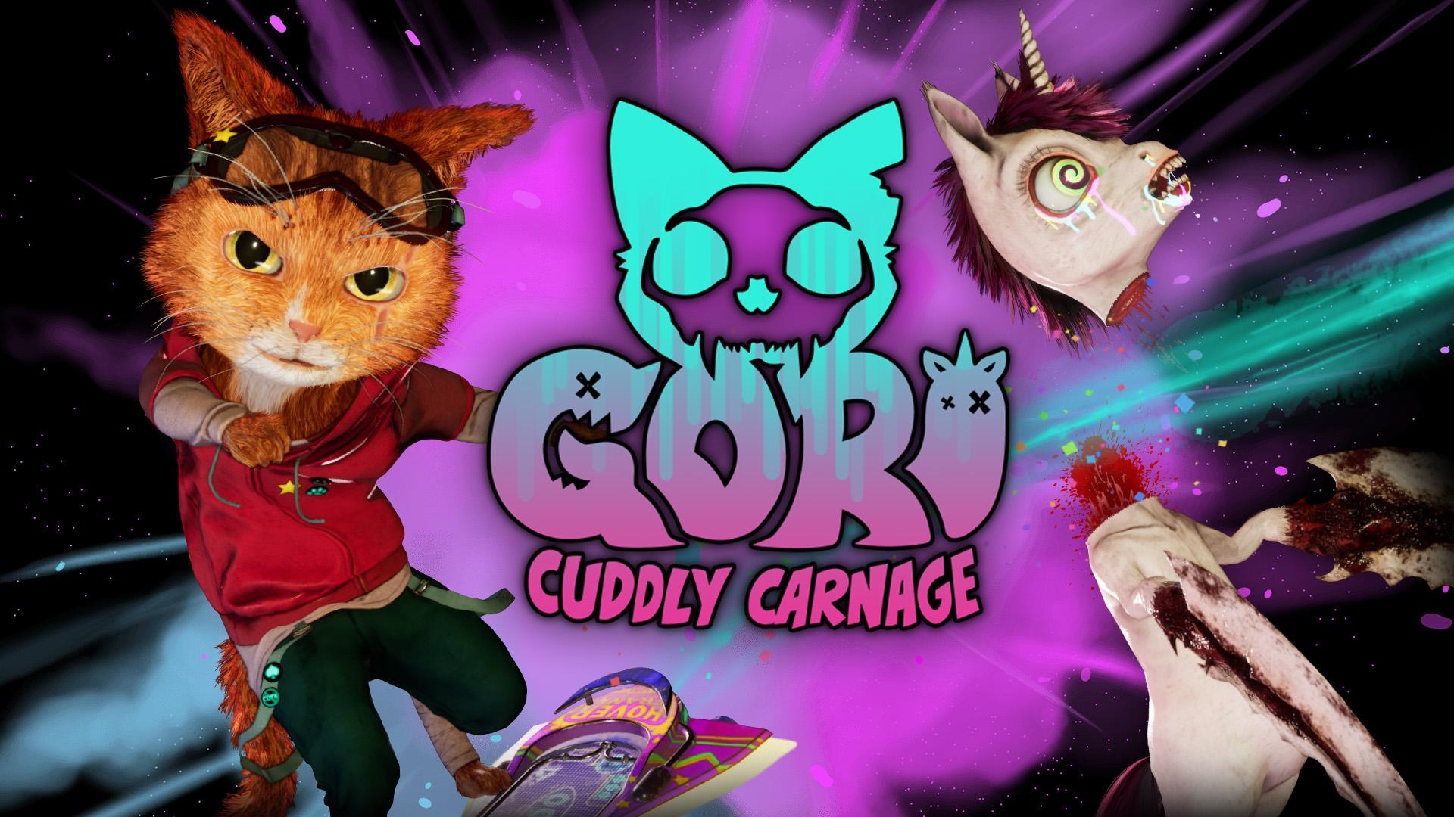

Gori: Cuddly Carnage Will Kick-Flip onto Nintendo Switch, PlayStation and Xbox in 2023

New Demo Available today in The Steam Bash Bash Event alongside a Brand-new Gameplay Trailer Revealing Radi-claw Range of Abilities In Hack ‘n’ Slash Adventure

Watford, UK - 20th September, 2022: Publisher Wired Productions and developers Angry Demon Studio today announce that the cuddly skate’n’slash ‘Gori: Cuddly Carnage’ is coming to Nintendo Switch, PlayStation 4, PlayStation 5 and the Xbox family of devices alongside the PC release in 2023. Players can get their hands on a new playable demo, available now as part of the Steam Bash Bash event.

Developed in Unreal Engine 5 and winner of the Epic MegaGrant, Gori: Cuddly Carnage is a third-person hack ‘n’ slash adventure set in a futuristic neon world of extreme and mutated toys. Play as the adorable feline hero, Gori, on a death-dealing hoverboard to save the cuddly crew from certain cat-astrophe. Purr-use the range of action-packed abilities players can look forward to in Gori: Cuddly Carnage in the brand-new trailer below.

Watch the Platform Announcement Trailer:
https://youtu.be/6roRGMTjkko

The Official Gori: Cuddly Carnage Discord also launches today and is home to dedicated content that cannot be found anywhere else. Come speak directly with the developers Angry Demon Studio, the positively chaotic minds behind the twisted and toy-filled world of Gori: Cuddly Carnage, and be first in the queue when the closed beta is announced!

“We’re thrilled to announce that our lovable hero, Gori, is kick-flipping his way to consoles in 2023, which we hope is meow-sic to everyone’s ears!”, said John Kalderon, CEO at Angry Demon Studio. “We hope gamers enjoy the brand-new trailer and discover more about the intense hoverboard combat in our adorable, yet deadly world of Gori: Cuddly Carnage!”

“We’re purr-leased that Gori: Cuddly Carnage is coming to both consoles and PC in 2023,” said Neil Broadhead, Head of Marketing at Wired Productions. “The Steam demo for our action-packed and foul-mouthed game, stuffed with intense destruction and brutal combat, is available now - and we cannot wait to see everyone’s reaction to it! ”

Gori: Cuddly Carnage will be releasing on PC, Nintendo Switch, PlayStation 4, PlayStation 5, Xbox Series X|S, and Xbox One in 2023.

For more information visit: https://wiredproductions.com/games/gori-cuddly-carnage/, follow Gori: Cuddly Carnage on Twitter, join the Official Discord and wishlist on Steam.

Download all assets via: https://media.wiredproductions.com/games/gori-cuddly-carnage/

PR Contacts:

Renaissance PR
Stefano Petrullo – Renaissance PR
stefano@renaissancepr.biz
+44 (0) 7828 692 315

Greg Jones – Renaissance PR
greg@renaissancepr.biz
+44 (0) 7867 788 079

Gabrielle Hibberd – Renaissance PR
gabrielle@renaissancepr.biz
+44 (0) 7429 046 311

Wired Productions
Tegan Kenney & Anastasia Denisova
press@wiredproductions.com

###

About Wired Productions
Wired Productions is an independent video games publisher based in Watford, UK. Wired has produced and published award-winning titles across all major platforms and its games are curated to deliver on its mantra: ‘Driven by Passion.’ Bringing games to market in both physical and digital media, recent notable launches include Arcade Paradise, Martha Is Dead, The Falconeer, Deliver Us The Moon. Upcoming titles include Tin Hearts, Tiny Troopers: Global Ops, The Last Worker, Gori: Cuddly Carnage, Hotel Architect and The Falconeer: Bulwark.
For a deeper dive into the Wired world, watch Wired Unplugged: http://wired.gg/wiredlive
Join the Wired community via: Wired Live | Twitter | Discord | YouTube | Twitch

About Angry Demon Studio

Angry Demon Studio is an independent game developer based in Skövde, Sweden, focused on creating high-quality, adrenaline-filled experiences and pushing the boundaries of what’s possible in small-scale game dev. Its debut title Unforgiving – a Northern Hymn was a hauntingly unforgettable slice of Nordic folk horror. The team explored these themes further with a striking vision of future viking terror in Apsulov: End of Gods, and is currently hard at work on the ultra-inventive, ultra-violent, ultra-cute skate-and-slasher Gori: Cuddly Carnage.

For more information, please follow ADS on Twitter or visit https://angrydemonstudio.com/

