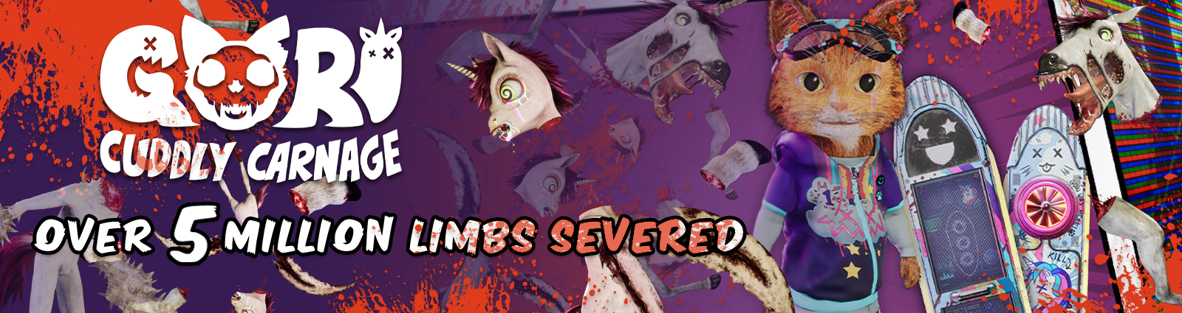

**Gori Cuddly Carnage Celebrates Over 5 million Unicorn Limbs Sliced up With a New Trailer and Day One Cosmetic!**

*Announced During FearFest 2023, Celebrate the Brutal Carnage Available in the Steam Demo, and the Eye Grabbing Day One Early Adoption Outfit.*

Watford, UK – 7th September, 2023: Publisher **Wired Productions** and developers **Angry Demon Studio today** announced that players of the PC demo of upcoming brutal Cat’ n’ Slash title **‘Gori: Cuddly Carnage’** have amassed an impressive 5,121,625 unicorn limbs removed since its launch earlier this year.   
  
To celebrate this spectacularly violent achievement (and commiserate with the one unicorn who apparently lost a single limb at the time of counting) a brand new trailer was revealed during Fear Fest - showcasing some of the bloody ‘glory kills’, and boss encounters from the early stages of the game. Players can download the demo on Steam now by visiting gori.wtf.

**Watch the Fear Fest Trailer:**<https://youtu.be/tmnr6B39h6o>

As well as showcasing Gori’s unique blend of adorably twisted creations and visceral combat - the trailer also revealed the ‘Day One’ cosmetic skins available for Gori and F.R.A.N.K as a thank you to those who wishlist the game and pick up the game during the launch period.

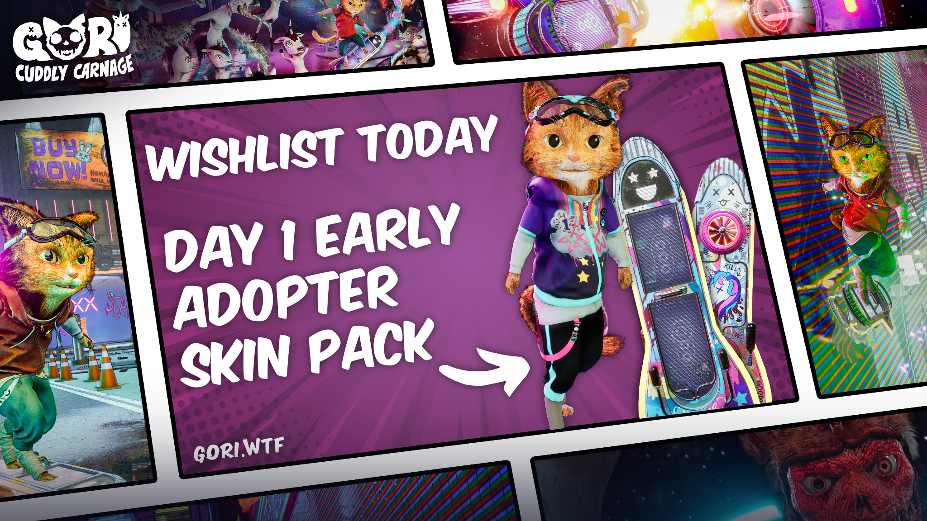

Developed in Unreal Engine 5 and winner of the Epic MegaGrant, *Gori: Cuddly Carnage* is an ultra violent third-person cat ‘n’ slash set in a futuristic neon world. A multilayered and unprecedented adventure, Gori: Cuddly Carnage is jam-packed with vivid and immersive environments whilst allowing the player to perform gnarly acrobatics in a positively brutal combat experience filled with high-speed and intense destruction.

***Gori: Cuddly Carnage* is coming to PC, Utomik, Nintendo Switch, PlayStation 4, PlayStation 5, Xbox Series X|S, and Xbox One.**

For more information visit**:** [**https://wiredproductions.com/games/gori-cuddly-carnage/**](https://wiredproductions.com/games/gori-cuddly-carnage/), follow **Gori: Cuddly Carnage** on **Twitter,** join the **Official Discord** and wishlist on[**Steam**](https://store.steampowered.com/app/1299690/Gori_Cuddly_Carnage/)**.**

Download all assets via:[**https://media.wiredproductions.com/games/gori-cuddly-carnage/**](https://media.wiredproductions.com/games/gori-cuddly-carnage/)

**PR Contacts:**

Anastasia Denisova

press@wiredproductions.com

**###**

**About Wired Productions**

Wired Productions is an independent video games publisher based in Watford, UK. Wired has produced and published award-winning titles across all major platforms and its games are curated to deliver on its mantra: ‘Driven by Passion.’ Bringing games to market in both physical and digital media, recent notable launches include Arcade Paradise, Martha Is Dead, The Last Worker and Tin Hearts.  
Upcoming titles include, Gori: Cuddly Carnage, Hotel Architect and Bulwark:Falconeer Chronicles

Find @WiredP on YouTube, Discord, and Twitter or search Wired Productions on Google.

**About Angry Demon Studio**

Angry Demon Studio is an independent game developer based in Skövde, Sweden, focused on creating high-quality, adrenaline-filled experiences and pushing the boundaries of what’s possible in small-scale game dev. Its debut title Unforgiving – a Northern Hymn was a hauntingly unforgettable slice of Nordic folk horror. The team explored these themes further with a striking vision of future viking terror in Apsulov: End of Gods, and is currently hard at work on the ultra-inventive, ultra-violent, ultra-cute skate-and-slasher Gori: Cuddly Carnage.

For more information, please follow ADS on Twitter or visit <https://angrydemonstudio.com/>