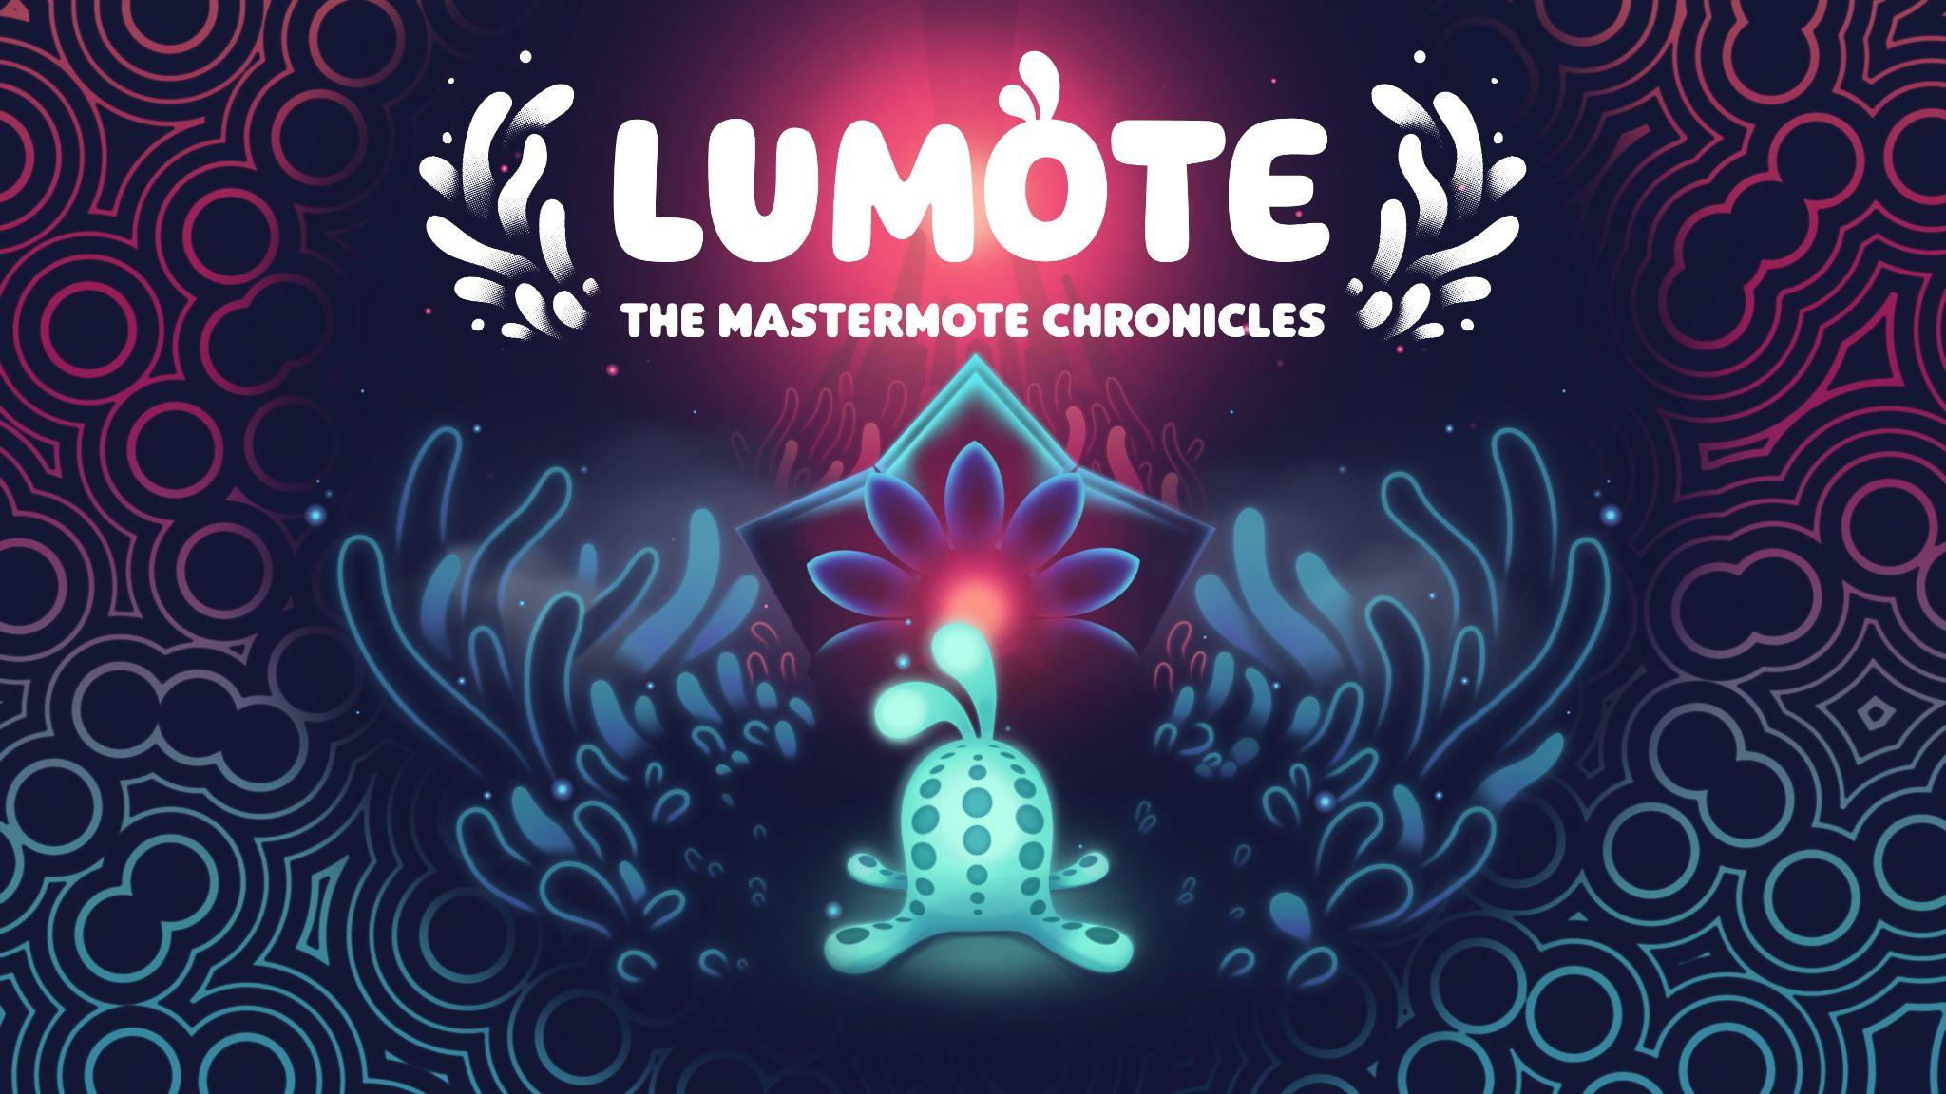

Charming Puzzle Platformer, Lumote: The Mastermote Chronicles Celebrates Launch with Illuminating Accolades Trailer

Demo available today as part of Wired Productions Publisher Sale

Watford, UK, 8th June, 2022 - Publisher Wired Productions and developer Luminawesome Games Ltd., are proud to celebrate the beautiful 3D puzzle platformer, Lumote: The Mastermote Chronicles, with a brand-new accolades trailer. After launching on April 21st, during PAX East 2022 where Lumote was the star of the show, the adventure has been described as “a Breath of Fresh Air” by AltChar and “a gem for puzzle players” by Game Tyrant. With glowing reviews, Lumote: The Mastermote Chronicles has been positively received from reviewers and players alike.

Created in the original rEngine as a passion project from the developers who worked on Sleeping Dogs, LittleBigPlanet Karting and Need For Speed: Underground, Lumote has squished, bopped and bounced into everyone’s hearts with Thumb Culture giving Lumote: The Mastermote Chronicles a “Platinum Award”. Amassing a score of ‘84’ on Metacritic, with a 97% positive review score on Steam, critics praised the title for its relaxing atmosphere, vibrant aesthetic, and excellent puzzle design.

Watch the Illuminating Accolades Trailer here:
https://youtu.be/HEGxpEJQJqk

Lumote: The Mastermote Chronicles sees players squish, bop and bounce through the Great Depths – an aquatic world filled with Motes; bioluminescent creatures who spend their lives deep in the Bioverse, living on the rhythms of an electronica soundscape.

The game expands upon the early access PC prototype, Lumote – delivering a complete version of the critically-acclaimed release, featuring a whole new game world in which players take control of the Mastermote to tackle 15 new head scratching puzzles, new gold collectable artifacts to find and general bug fixes and graphical improvements.

“Thank you to the players and reviewers, who have fallen in love with the adorable (and squishy) Lumote.” Said Neil Broadhead, Head of Marketing at Wired Productions. “We are so proud of the team at Luminawesome Games who have been working on this project since 2015. Lumote: The Mastermote Chronicles is truly deserving of the praise it has received.”

“Thank you to the community for their amazing feedback for Lumote: The Mastermote Chronicles.” Said Kyle Rocha, co-founder at Luminawesome Games. “This has been such a rewarding journey and we are thankful to everyone who has been a part of it.”

The limited physical edition of the game, available on Nintendo Switch and PlayStation 4, contains a double-sided folded poster, reversible inlay, a unique set of stickers featuring the bioluminescent hero, plus a digital download for the Lumote EP, and, if that wasn’t enough, instructions to crochet your very own Lumote! The physical release is available on PlayStation 4 for €19.99 / $19.99 / £15.99 and Nintendo Switch for €29.99 / $29.99 / £24.99, and can be ordered now via the Wired Productions Store.

Lumote: The Mastermote Chronicles is available now for Google Stadia, Nintendo Switch, PlayStation 4, Xbox One, Steam, GOG, Epic Games Store, and Utomik.

For more information, visit https://wiredproductions.com/games/lumote/ follow us on Twitter or join the official Discord.

###

PR Contacts
Tegan Kenney & Anastasia Denisova | press@wiredproductions.com
About Wired Productions
Wired Productions is an independent video games publisher based in Watford, UK. Wired has produced and published award-winning titles across all major platforms and its games are curated to deliver on its mantra: ‘Driven by Passion.’ Bringing games to market in both physical and digital media, notable launches to date include Martha Is Dead, The Falconeer, Those Who Remain, Deliver Us The Moon, Close to the Sun, GRIP: Combat Racing, Victor Vran: Overkill Edition, Max: The Curse of Brotherhood and The Town of Light. Recently, Wired Productions announced its upcoming slate of titles during Wired Direct. Upcoming titles include Lumote, Arcade Paradise, Tin Hearts, Tiny Troopers: Global Ops and The Last Worker.
Join the Wired community via: Wired Live | Twitter | Discord | YouTube | Twitch
About Luminawesome Games Ltd
Luminawesome’s humble beginnings came from winning an unreal game jam with the initial concept of Bump, which Kyle and Michelle Rocha fell in love with and developed into Lumote. Originally from Cambridge, Ontario, Kyle was recruited by United Front Games to work on Sleeping Dogs. With an ethos of being environmentally friendly and green, this is brought out in the game showing their own creative twist on an underwater world.
https://luminawesome.com/

