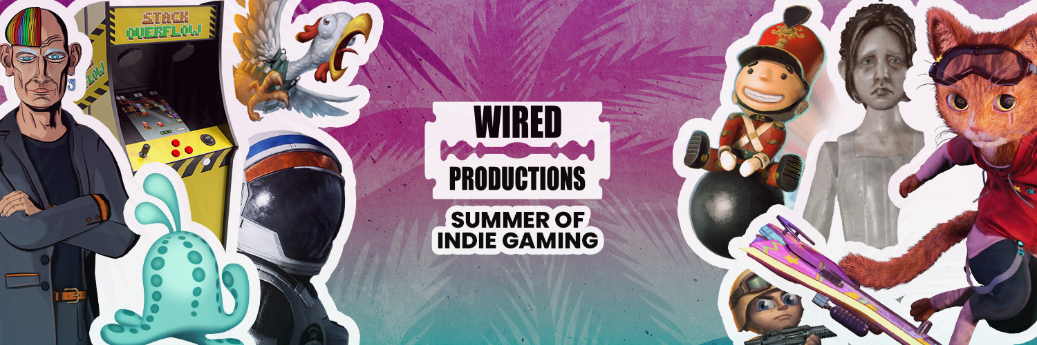

Wired Productions Announces its Summer of Indie Gaming with Debut Demos for The Last Worker and Tin Hearts Available Today!

New trailers for The Last Worker and Gori: Cuddly Carnage also revealed during IGN’s Summer of Gaming and the Guerrilla Collective

Watford, UK, 13th June, 2022 - Publisher Wired Productions today announces its ‘Summer of Indie Gaming’ with a line-up of thrilling demos, game launches, trailers, and so much more from specially curated and original indie titles, beginning now through to the end of August. With news to come on the long-awaited release date of the 90’s fuelled retro adventure Arcade Paradise, the first person narrative adventure The Last Worker and the immersive puzzle adventure, Tin Hearts, and the long-awaited launch of the Black Label Collection this season is truly the Summer of Indie Gaming!

Wired’s Summer of Indie Gaming Schedule Includes:

- 3rd - 10th June - Steam Publisher Sale
- 8th June - OTK Festival [Gori: Cuddy Carnage]
- 9th June - Upload VR Showcase [Tin Hearts]
- 10th June - IGN Summer of Gaming [Gori: Cuddly Carnage and The Last Worker]
- 11th June - Guerrilla Collective [The Last Worker]
- 13th June - Steam Next Fest Debut Demos for The Last Worker and Tin Hearts
- 13th June - AVICII VR Meta Quest 2 Daily Deal (ends midnight)
- 15th June - New trailer for Tin Hearts
- 23rd June - Deliver Us The Moon Next-Gen Launch Day
- 29th June - Something special for Arcade Paradise
- Deals, sales and more to be revealed!

Play The Last Worker Demo now: https://store.steampowered.com/app/1579280/The_Last_Worker/

Play the Tin Hearts Demo now:
https://store.steampowered.com/app/1831700/Tin_Hearts/

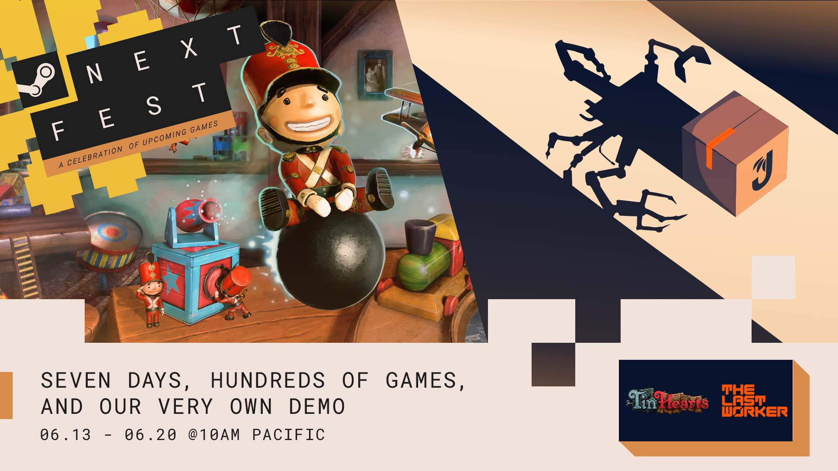

The Summer of Indie Gaming campaign kicks off with debut demos during the Steam Next Fest for The Last Worker and Tin Hearts. Alongside this, brand-new trailers for The Last Worker and the ultra fast-paced ‘skate-and slash’ Gori: Cuddly Carnage (Angry Demon Studio) were unveiled during the IGN Expo, with The Last Worker also featuring during the Guerrilla Collective 3.

The satirical new trailer from The Last Worker, which made its debut during the IGN Expo, follows a typical day at the The Jüngle Fulfilment Centre (JFC-1), where nothing can stop progress, Kurt (Ólafur Darri Ólafsson) and Skew (Jason Isaacs) are faced with the predicament of what to do 'when nature calls'. As is the case for many warehouse employees, when you have packages to ship, sometimes a bottle is your only option. With a sneak peek of the gameplay and the satirical humor found within The Last Worker, day 9,126 is (unfortunately) an average day like any other at Jüngle.

Watch The Last Worker “When Nature Calls” Trailer:
https://youtu.be/iWcm2KiOfp8

The Last Worker will be dispatched in 2022 on Steam, Epic Games Store, GOG, Nintendo Switch, PlayStation 5, Xbox Series X|S and Meta Quest 2. The Last Worker demo is available now via Steam.
The Last Worker was the only game in competition at the 78th Venice International Film Festival (2021), where it introduced the festival’s audience to the game’s opening chapter.
For more information, check out the latest news and Wishlist via Steam, visit the official website for The Last Worker or follow on Twitter or Instagram.

In addition, IGN viewers had the opportunity to meet Gori who isn’t a Stray cat, instead he’s a murder-kitty with a bad cattitude, as he tears through hordes of mutant unicorns on the sentient razor-sharp hoverboard F.R.A.N.K, in this radi-claw new gameplay trailer for Gori: Cuddly Carnage.

Watch the Gori: Cuddly Carnage ‘Bad Cattitude’ Trailer:
https://youtu.be/xfQi6eVv7tc

The third-person ‘skate ‘n slash’ set in a neon-glowing futuristic world, is filled with intense destruction and fast-paced combat. Join Gori, F.R.A.N.K and CH1-P as they are unwillingly dragged into battle to save their own lives and stop the carnage of the adorable Army and its dark leaders!

Further information about Gori: Cuddly Carnage will be revealed throughout the coming months.

For more information, visit: https://wiredproductions.com/games/gori-cuddly-carnage/

With more news to be revealed throughout Wired's Summer of Indie Gaming, 2022 will see the launch of Arcade Paradise, Tin Hearts and The Last Worker. Indie fans can stay up to date with all of Wired’s announcements via the Wired Productions Youtube Channel.

Media Enquiries
Tegan Kenney & Anastasia Denisova | press@wiredproductions.com
###
About Wired Productions
Wired Productions is an independent video games publisher based in Watford, UK. Wired has produced and published award-winning titles across all major platforms and its games are curated to deliver on its mantra: ‘Driven by Passion.’ Bringing games to market in both physical and digital media, notable launches to date include Martha Is Dead, The Falconeer, Those Who Remain, Deliver Us The Moon, Close to the Sun, GRIP: Combat Racing, Victor Vran: Overkill Edition, Max: The Curse of Brotherhood and The Town of Light. Recently, Wired Productions announced its upcoming slate of titles during Wired Direct. Upcoming titles include Lumote: The Mastermote Chronicles, Arcade Paradise, Gori: Cuddly Carnage, Tin Hearts, Tiny Troopers: Global Ops and The Last Worker.
Join the Wired community via: Wired Live | Twitter | Discord | YouTube | Twitch

