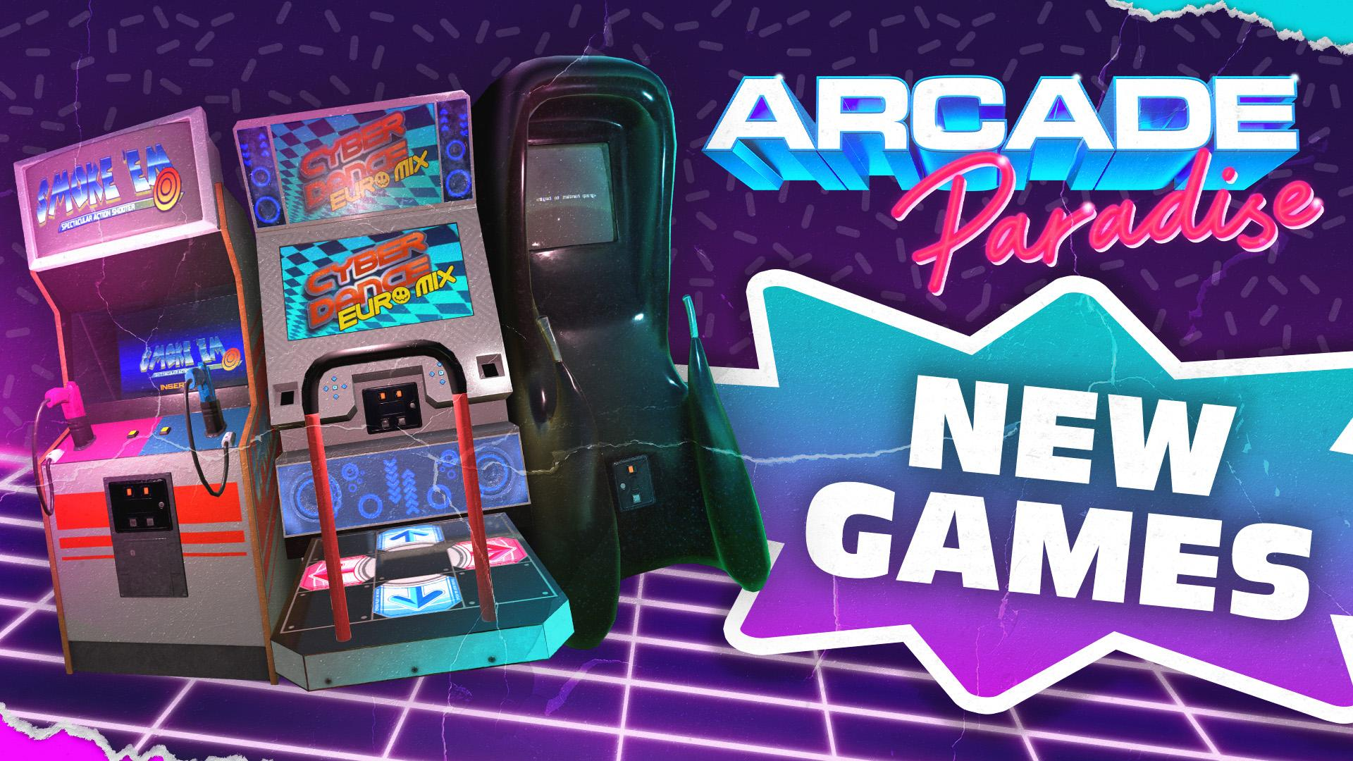

A New Challenger Has Appeared - Arcade Paradise Expands with Three New Cabinets DLC and Official Soundtrack Release Available Today!

Prepare to shoot, dance, climb (and continue chasing high scores!) with Empathy, Smoke ‘em and CyberDance Euromix

Watford, UK, 3rd November, 2022 - Publisher Wired Productions and award winning independent studio, Nosebleed Interactive, today announce an expansion for 90’s arcade and light management sim combo game, Arcade Paradise. ‘Coin-Op Pack #1 includes three brand-new arcade cabinets which represents the first step on a roadmap for future content to be released over the coming months. To celebrate Coin-Op Pack #1, the Arcade Paradise Double Vinyl LP also launches today! Inspired by the game’s early 90’s setting - the era of the limited edition, there will only be 1000 pressings released.

Coin-Op Pack #1 adds three brand-new games to Arcade Paradise, Empathy, Smoke ‘em and CyberDance Euromix, available to purchase as a bundle for $3.99 / €3.99 / £3.49, or individually for $1.99 / €1.99 / £1.79. For new players, the Wired Store Sale also begins today, offering a 10% discount across all products including Arcade Paradise on all platforms.

Watch the Coin-Op Pack #1 DLC Reveal Trailer:
https://youtu.be/3DdwNOeG1c8

About Coin-Op Pack #1

Empathy
Time to grasp the handles and ascend the mountain whilst avoiding being hit by rocks from unbelievers. The longer you survive the more points you score. Forsake loneliness. Feel togetherness. Ascend. How high can you go?

Smoke ‘em
Aim. Fire. Reload. It’s time to test your sharpshooting skills against the clock in this supremely fun high scoring 2 player shooting range.

Cyberdance EuroMix
If your name's not down, you're not coming in. Luckily for you, it is
Cyberdance EuroMix is the rave focused follow up to Arcade Paradise’s smash hit dancing sensation, Cyber Dance - with updated graphics and next generation widescreen technology. Pick your tune, then coordinate your movements in time with the beat. The closer to matching the beat you tap, the more you'll score! Prepare to dance your socks off. For one or two players.

The Coin-Op Pack #1 is priced at $3.99 / €3.99 / £3.49 or the arcade games are available individually for $1.99 / €1.99 / £1.79

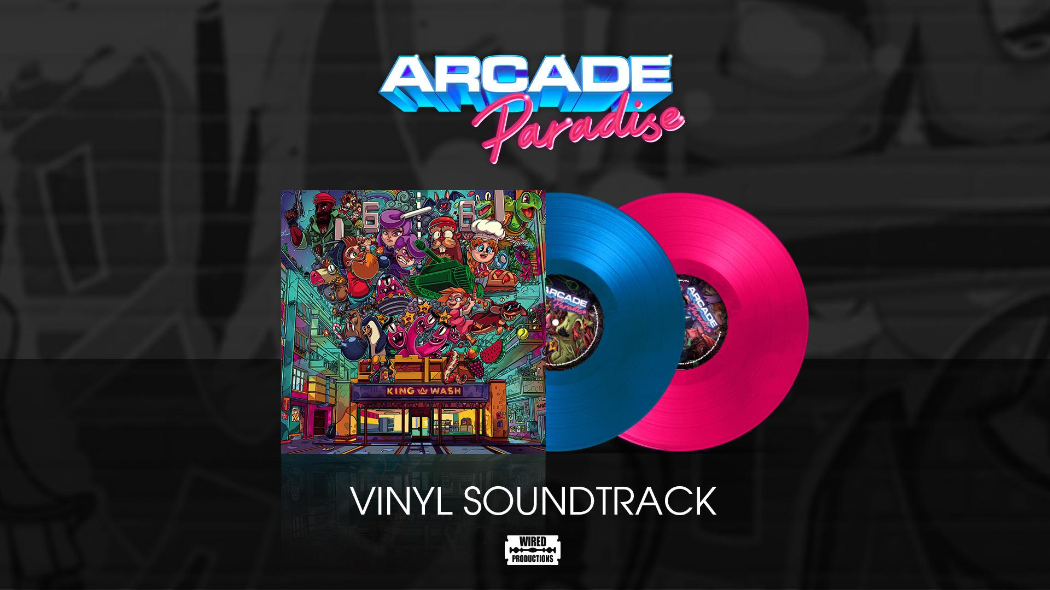

The Arcade Paradise Double Vinyl Soundtrack features electrifying music by writer and producer Kieron Pepper (ex-Prodigy live drummer, 1997-2007) and is mastered by Bob Macc / Subvert, produced by Video Games Music Label, Black Razor Records. Featuring original 8-bit illustrated album artwork by David Sossella, the Double Vinyl is housed in a gatefold sleeve.

Avid listeners will be transported to the early 90’s in which the game is set, a true love letter to the skaters, ravers, and sticky arcade carpets of a time where arcades ruled the world. Meticulously crafted with collectors in mind, the premium Double Vinyl is limited to 1000 eye-catching blue and pink vinyl pressings and includes a full digital download with bonus tracks too.

The Arcade Paradise Double Vinyl soundtrack is available to purchase now from the Wired Productions store for £35.00.

For more information, visit https://wiredproductions.com/games/arcade-paradise/, follow Arcade Paradise on Twitter, join the Official Discord, and wishlist on Steam.

Download all assets via: https://media.wiredproductions.com/
Request DLC Review Code via: https://requestkey.net/i3mwxq

PR Contacts:

Renaissance PR
Stefano Petrullo – Renaissance PR
stefano@renaissancepr.biz
+44 (0) 7828 692 315
Greg Jones – Renaissance PR
greg@renaissancepr.biz
+44 (0) 7867 788 079
Wired Productions
Tegan Kenney & Anastasia Denisova
press@wiredproductions.com
About Wired Productions
Wired Productions is an independent video games publisher based in Watford, UK. Wired has produced and published award-winning titles across all major platforms and its games are curated to deliver on its mantra: ‘Driven by Passion.’ Bringing games to market in both physical and digital media, recent notable launches include Arcade Paradise, Martha Is Dead, The Falconeer, Deliver Us The Moon. Upcoming titles include Tin Hearts, Tiny Troopers: Global Ops, The Last Worker, Gori: Cuddly Carnage, Hotel Architect and The Falconeer: Bulwark.
For a deeper dive into the Wired world, watch Wired Unplugged: http://wired.gg/wiredlive
And for those who love music and video games, head to Black Razor: https://blackrazorrecords.bandcamp.com/album/arcade-paradise-ep
Join the Wired community via: Wired Live | Twitter | Discord | YouTube | Twitch
About Nosebleed Interactive
Nosebleed Interactive is a multi-award-winning independent studio based in Newcastle upon Tyne, in the heart of the North East of England. After critical hit Vostok Inc., Nosebleed released the 90’s arcade and light management sim, Arcade Paradise, their biggest game to date.
https://www.nosebleedinteractive.com/
About Black Razor Records
Black Razor Records launched in 2022 and is a wholly owned label of Wired Productions. Its mission is to bridge the gap between the video game and music worlds and to provide music creators a platform to showcase and commercialise their talent. All music originates from video games, whether in-game or for promotional purposes. By collaborating with great writers and producers, the loadout is complete. Music is in the DNA. Game on!
Black Razor Records latest commercial release is the Arcade Paradise Official Soundtrack - featuring music by writer and producer Kieron Pepper (ex-Prodigy live drummer, 1997-2007) and is mastered by Bob Macc / Subvert.
For more information visit: www.BlackRazorRecords.com

