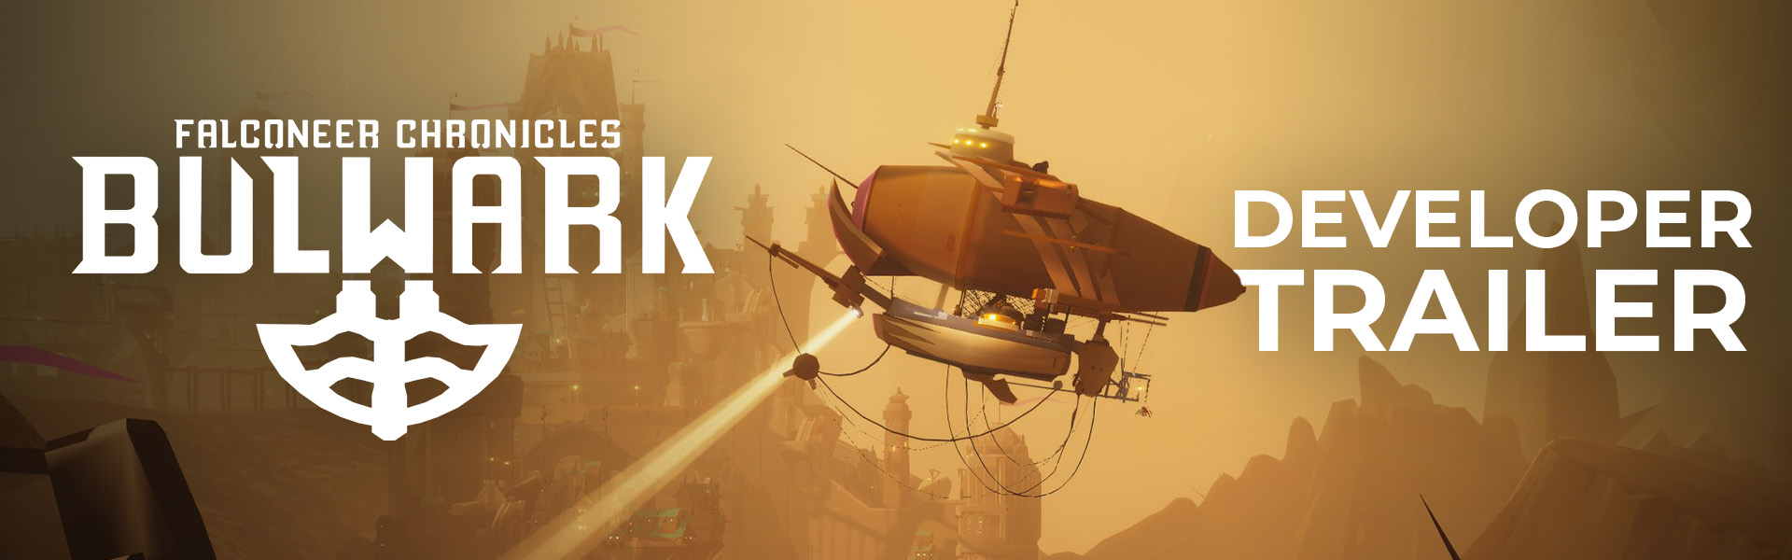

**Bulwark: Falconeer Chronicles Evolving Demo Soaring to New Heights in Steam Next Fest**

*Solo Developer Tomas Sala delivers new talkthrough video highlighting the limitless freebuild mode*

**Watford, UK - 16th June, 2023:** Publisher **Wired Productions** and solo developer , **Tomas Sala**, are delighted to announce the expansion of the Evolving Demo for freeform city builder, ***Bulwark: Falconeer Chronicles***, ahead of the Steam Next Fest event.   
  
*Bulwark : Falconeer Chronicles*, A fantasy open world building sandbox that subverts you into exploring your own chaotic creativity.   
  
**Evolving Demo**

The Evolving Demo has been cooking and percolating for several months, its purpose is to streamline the experimental controls that combine open world exploration with organic building and tower design in a sprawling open 3d world, players can now jump in with a host of improvements and new content:

* A political system that monitors which refugees you bring into your settlement and how they affect the balance of factions in your settlement
* Unlock a dominant faction that in turn will allow more advanced captains and commanders of that faction to join you.
* Enroll aggressive Faction Leaders that unlock even more new building options and vehicles as well as inciting raids and combat encounters.
* The introduction of new captains and combat captains with their own set of perks
* A campaign option to skip the tutorial and dive right into the action (for hardcore players).
* New random events and encounters (Including Pirate Skullship Captains!)
* An increased range for buildings to snap, allowing for larger sprawling constructions

**Watch the *Bulwark: Falconeer Chronicles* Free Build Gameplay Reveal Trailer**

[**https://youtu.be/WzlDVcNaeS4**](https://youtu.be/WzlDVcNaeS4)

Players can now try out the latest version of this experimental building game that combines organic and exploratory building with a fully open world. In Bulwark players create their own dream fortresses and settlements across the craggy rocks and sharp peaks of its world. Build up or down, left or right, build anywhere, build by exploring what’s possible.   
  
Just as *The Falconeer* was Tomas’s attempt to take the players into an exploration of internal conflict. Bulwark is his attempt to take players to the same source from which his own imagination springs, experimentation,curiosity and chaos. The only thing that tempers the player’s wildest creations is that the world is alive and filled with other people and the factional strife that was first introduced in *The Falconeer*. A living canvas for the player to explore.

You can play the Evolving demo and Wishlist *Bulwark: Falconeer Chronicles* on [Steam](https://store.steampowered.com/app/290100/Bulwark_Falconeer_Chronicles) now. Further information will be revealed throughout the coming months. To stay up to date visit [FalconeerChronicles.com](http://falconeerchronicles.com/), chat on [Twitter](https://twitter.com/WiredP) or join the official [Discord](https://discord.com/invite/falconeer) by searching *Falconeer Chronicles*.

Download all assets via: <https://media.wiredproductions.com/games/bulwark-falconeer-chronicles/>

**PR Contacts:**

**Renaissance PR**

Stefano Petrullo – Renaissance PR  
Stefano@renaissancepr.biz   
+44 (0) 7828 692 315

Sam Faulkner – Renaissance PR  
Sam@renaissancepr.biz

Wired Productions  
Anastasia Denisova  
press@wiredproductions.com

**###**

**About Wired Productions**

Wired Productions is an independent video games publisher based in Watford, UK. Wired has produced and published award-winning titles across all major platforms and its games are curated to deliver on its mantra: ‘Driven by Passion.’ Bringing games to market in both physical and digital media, recent notable launches include *Tin Hearts*, *The Last Worker*, *Tiny Troopers: Global Ops*, *Arcade Paradise*, *Martha Is Dead*, *The Falconeer*, and *Deliver Us The Moon*. Upcoming titles include *Gori: Cuddly Carnage*, *Hotel Architect* and *Bulwark: Falconeer Chronicles*.

Join the Wired community via @wiredp

**About Tomas Sala**

BAFTA nominated Tomas Sala is an independent game artist and designer as well as the co-founder of game studio Little Chicken Game Company. Known to most gamers for his exotic Skyrim Mod series: *Moonpath to Elsweyr*, Tomas has developed a unique visual style over the years that have helped turn games such as *Rekt!* (iOS/Switch), *SXPD* (iOS) and *TrackLab* (PSVR) into unique visual and interactive experiences, before creating the critically acclaimed *The Falconeer*.