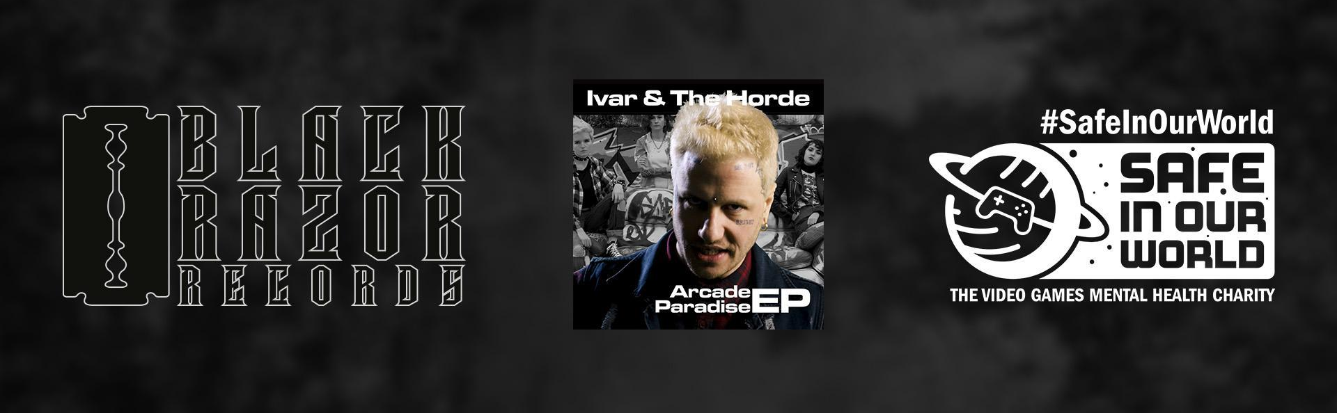

Wired Productions Announces Music Label - Black Razor Records

Arcade Paradise EP Created by ex-Prodigy Live Drummer Debuts with all Proceeds Donated to Video Games Charity - Safe In Our world

Watford, UK - 22nd September 2022: Video Game Publisher Wired Productions today launched a new music label, Black Razor Records, whose aim is to bridge the gap between the video game and music worlds. Its debut release is Arcade Paradise, a 4 track EP from the video game of the same name. The Arcade Paradise EP is a collaboration between writers Kieron Pepper (ex-Prodigy live drummer 1997-2007), Ben Pickersgill (Brighton producer [Klax, Critical]), and singer Stu Brootal (Ivar & The Horde). All proceeds from sales via Bandcamp will be donated to the video games mental health charity, Safe In Our World.

Watch the Arcade Paradise Music Video:
https://youtu.be/GVfC5C5FopU

Purchase the Arcade Paradise EP via:
https://blackrazorrecords.bandcamp.com/releases

Available on all Streaming Platforms via:
https://wired.gg/ArcadeEP

The charity EP features in the video game of the same name, Arcade Paradise, developed by award-winning independent studio, Nosebleed Interactive, and launched on the 11th August. The titular song Arcade Paradise follows the story of Ashley and their dysfunctional relationship with their father, combining anger and determination to show just what can be done with the right focus.

Set up in 2019, the main goal of Safe In Our World is to create and foster mental health awareness within the video game industry for gamers and industry people worldwide. The charity supports people from all walks of life, including those like Ashley, the protagonist of the Arcade Paradise video game, who find themselves under immense pressure and have to juggle everyday responsibilities with challenging personal relationships. Ashley’s story is just one but resonates with many.

Watch Leo Zullo, Stu Brootal and Kieron Pepper discuss the Arcade Paradise collaboration with Safe In Our World:
https://youtu.be/1eaAI3q1p3Q

”The story of Ashley and their struggle with authority is one we have all experienced at some point in our lives. When we were briefed about the theme, it was easy to quickly understand and relate to” said Kieron Pepper, composer and producer for the Arcade Paradise EP. “Stu Brootal and his crew [Ivar & The Horde] smash it out of the park with the right level of anger and energy.”

“I hope gamers and music fans alike appreciate the song’s message and how the money it raises will contribute to the great work that Safe In Our World does” said Leo Zullo, Managing Director at Wired Productions. “Music has always been in the DNA of Wired Productions, so setting up a music label is a natural step for us. As we are independent we choose the projects we work on, so our first release combines our favourite things… video games, great music and supporting a video game mental health charity close to our hearts… because we can!”

The Arcade Paradise charity EP is available to purchase today for £3.00, and all proceeds from Bandcamp will go to Safe In Our World.
Arcade Paradise EP is also available on all streaming platforms.

Arcade Paradise EP Tracklist:
- Ivar & The Horde - Arcade Paradise (Explicit)
- Ivar & The Horde - Arcade Paradise (Future Funk Squad Electro Mix)
- Ivar & The Horde - Arcade Paradise (Radio Edit)
- Ivar & The Horde - Arcade Paradise (Instrumental)

For more information visit: https://blackrazorrecords.bandcamp.com/releases

Download all assets via the Black Razor Records Press Kit.

PR Contacts:
Renaissance PR
Stefano Petrullo – Renaissance PR
stefano@renaissancepr.biz
+44 (0) 7828 692 315
Greg Jones – Renaissance PR
greg@renaissancepr.biz
+44 (0) 7867 788 079
Gabrielle Hibberd – Renaissance PR
gabrielle@renaissancepr.biz
+44 (0) 7429 046 311
Wired Productions
Tegan Kenney & Anastasia Denisova
press@wiredproductions.com
About Black Razor Records
Black Razor Records launched in 2022 and is a wholly owned label of Wired Productions. Its mission is to bridge the gap between the video game and music worlds and to provide music creators a platform to showcase and commercialise their talent. All music originates from video games, whether in-game or for promotional purposes. By collaborating with great writers and producers, the loadout is complete. Music is in the DNA. Game on!
Black Razor Records first commercial release is Arcade Paradise EP – a collaboration between writers Kieron Pepper (ex-Prodigy live drummer 1997-2007), Ben Pickersgill (Brighton producer [Klax, Critical]), and singer Stu Brootal (Ivar & The Horde). All proceeds from this first release via Bandcamp, is to be donated to the video games mental health charity, Safe In Our World.
For more information visit: www.BlackRazorRecords.com
About Wired Productions
Wired Productions is an independent video games publisher based in Watford, UK. Wired has produced and published award-winning titles across all major platforms and its games are curated to deliver on its mantra: ‘Driven by Passion.’ Bringing games to market in both physical and digital media, recent notable launches include Arcade Paradise, Martha Is Dead, The Falconeer, Deliver Us The Moon. Upcoming titles include Tin Hearts, Tiny Troopers: Global Ops, The Last Worker, Gori: Cuddly Carnage, Hotel Architect and The Falconeer: Bulwark.
For a deeper dive into the Wired world, watch Wired Unplugged: http://wired.gg/wiredlive
Join the Wired community via: Wired Live | Twitter | Discord | YouTube | Twitch
About Safe In Our World
Safe In Our World is a registered charity in England and Wales no. 1183344. A team of seasoned gaming veterans passionate about mental health brainstormed for over two years over ways they could make a difference. Launched on World Mental Health Day on October 10th, 2019, its aims are to raise awareness of mental health issues within the video games industry, and to provide resources, signpost help, and to drive change for everyone connected with the industry, for developers, publishers and service providers, to content creators and players. Its initial mission is to create an online destination where people can seek help, gain access to resources and information, and discover stories from real people within and surrounding the games industry, with more detailed policies available via the website. Safe In Our World is a worldwide hub accessible for anyone in need.
About Kieron Pepper
Composer Kieron Pepper is a multi-instrumentalist, songwriter and producer, known primarily for his work as the first live drummer for The Prodigy (1997-2007) and subsequently as a member of The Radiophonic Workshop, bass player for Brit Pop legends Sleeper and co-writer/producer for a variety of acts from Wargasm (UK) to Alabama 3. In between these passions he is the Director of Artist Development at WaterBear College of Music, mentoring new artists, bands and producers.
About Ben Pickersgill
Ben Pickersgill is an audio designer and composer with a breadth of work ranging from regular featured tracks on Noisia's radio show as a Critical Music artist to being commissioned to remix David Bowie's 'Heroes'. He was also a member of drum & bass crew Klax, and is currently working as an audio designer with credits on upcoming games such as 'Hogwarts Legacy' and Arkane's 'Redfall'.
About Stu Brootal (Ivar & The Horde)
Stu Brootal, the prodigal son returning to the UK motherland from his teenage years in Texas, already has a strong catalogue of self-released albums under his belt; honestly chronicling the highs and lows of his journey so far, through exquisitely executed hip-hop flows and self-produced beats. After teaming up with Kieron Pepper (ex-Prodigy drummer, Wargasm co-producer) for the BaseFace release ‘Lotus’, the door opened up to some stellar collaborations with Future Funk Squad, championed by The Crystal Method, and various compositions within the gaming world. Stu is currently in the laboratory cooking up a new album, as well as running his own tattoo temple.

