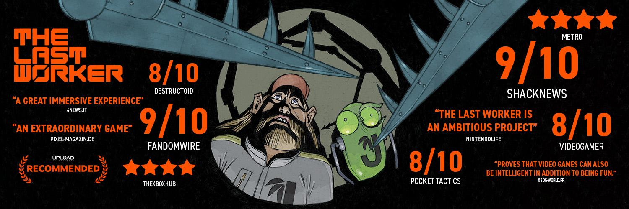
The Last Worker Celebrates Launch with Positive Jüngle Performance Rating in Brand-New Accolades Trailer
Employees not fired, hooray!
Watford, UK – 28th April, 2023 – Publisher Wired Productions, Writer/Director Jörg Tittel, and pioneering independent games studio Wolf & Wood, are proud to celebrate the launch and reception of the immersive narrative adventure, The Last Worker, with a brand-new accolades trailer following its launch on March 30th.
Described as “one of the years best narratives” by Shacknews, “an admirable pastiche of modern capitalist culture”, by Pocket Tactics and “an extraordinary game” by Pixel Magazin, along with a ‘Recommended’ from UploadVR, The Last Worker has been positively received from reviewers and players alike in both flat screen and VR formats.’
Watch The Last Worker Accolades Trailer:
[https://youtu.be/AkLs6rcs1aI]

The Last Worker is a first-person narrative adventure centred around humanity’s struggle in an increasingly automated world, where humans are being replaced by robots. Created from the ground up to deliver both VR and flat-packed experiences, the game combines a hand-crafted art style created in collaboration with comics legend Mick McMahon (Judge Dredd, 2000 AD) and unique, immersive gameplay mechanics, seamlessly interwoven into a narrative game like no other.
The Last Worker was the only game in competition at the 78th Venice International Film Festival (2021) and delivers an emotional, thought-provoking story filled with rich characters performed by an all-star cast including Jason Isaacs (Harry Potter, Star Trek Discovery), Ólafur Darri Ólafsson (The Meg, True Detective), Clare-Hope Ashitey (Riviera, Children of Men), David Hewlett (The Shape of Water, Oddworld New’n’Tasty), Zelda Williams (The Legend of Korra) and Tommie Earl Jenkins (Death Stranding, Wednesday). The Last Worker is scored by Oliver Kraus, known for his collaborations with the likes of Adele, Sia, and Florence and the Machine.
The Last Worker is out now on Meta Quest 2, PSVR2, PS5, Nintendo Switch, Xbox Series X|S and PCVR alongside a PC release on Steam, Epic Games Store and GOG. Alternatively players can access The Last Worker through streaming service, Utomik.
Players can also support capitalism by ordering the Jüngle Pronto physical edition. Packed with a reversible sleeve, Jüngle stickers and a double-sided poster, fans can grab a copy from the likes of Amazon (not awkward) at just £19.99 / $24.99 / €24.99 for the PlayStation 5 version and £24.99 / $29.99 / €29.99 for Nintendo Switch.
Find out where to buy via the Wired Productions Website.
For more information, search @TheLastWorker on Twitter, Instagram or Google.
Download all assets via: https://media.wiredproductions.com/games/the-last-worker/
PR Contacts:
Renaissance PR
Stefano Petrullo – Renaissance PR
stefano@renaissancepr.biz
+44 (0) 7828 692 315
Greg Jones – Renaissance PR
greg@renaissancepr.biz
+44 (0) 7867 788 079
Wired Productions
Anastasia Denisova
press@wiredproductions.com
###
About Wired Productions
Wired Productions is an independent video games publisher based in Watford, UK. Wired has produced and published award-winning titles across all major platforms and its games are curated to deliver on its mantra: ‘Driven by Passion.’ Bringing games to market in both physical and digital media, recent notable launches include The Last Worker, Tiny Troopers: Global Ops, Arcade Paradise, Martha Is Dead, The Falconeer, Deliver Us The Moon. Upcoming titles include Tin Hearts, The Last Worker, Gori: Cuddly Carnage, Hotel Architect and Bulwark: Falconeer Chronicles.
Find @WiredP on YouTube, Discord, Twitter or search Wired Productions on google.
About Jörg Tittel / Oiffy
Jörg Tittel is a London based writer, director and producer. In 2011, he founded Oiffy with director/writer Alex Helfrecht and producer Philip Munger. Their debut feature was THE WHITE KING starring Jonathan Pryce and Fiona Shaw, which Jörg co-directed with Alex. Jörg’s satirical graphic novel RICKY ROUSE HAS A GUN was a Boston Globe Book of the Year. Oiffy’s next feature film is the painted-animated musical adventure drama A WINTER’S JOURNEY starring John Malkovich and Jason Isaacs, based on Franz Schubert’s “Winterreise” and animated by the artists behind the Oscar nominated LOVING VINCENT. Distributed by Sony Pictures Classics, it is the first feature film to be made with the help of PlayStation and Media Molecule’s BAFTA winning Dreams™. Together with Frédérick Raynal (creator of Alone in the Dark), he’s been working on SKEW, a spin-off of The Last Worker for Playdate coming in early 2023. Search @NewJorg on Twitter.
About Wolf & Wood
Wolf & Wood are an independent games studio based in the North East of England. The small but multi-talented team have written, designed and developed a number of first-person narrative titles including The Exorcist: Legion VR, which expands on the Oscar-winning horror franchise created by William Peter Blatty and have self-published their own award-winning IP, A Chair in a Room: Greenwater and the rock’n’roll riot, Hotel R’n’R. Search WolfandWood on Twitter or Google for more.

