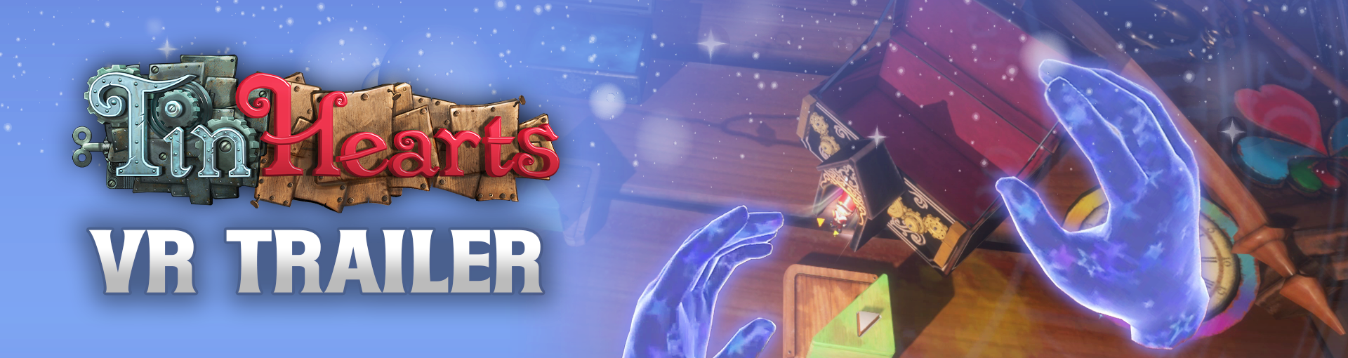

**Immersive Tin Hearts VR Trailer Reveals Extensive Gameplay Coming to PS VR2 and PC VR**

*Unveiled During Last Night's Future Games Show Gamescom Showcase, Take a Closer Look at the Narrative Puzzle Adventure in VR*

**Watford, UK - 24th August, 2023:** Publisher **Wired Productions** and Developer **Rogue Sun,** crafters of artisanal entertainment, have today revealed a brand-new VR trailer showcasing the immersive gameplay for the critically acclaimed narrative puzzle adventure *Tin Hearts*, which will be releasing for PC VR and PS VR2 later this year. *Tin Hearts* is also available now on PC and consoles after being critically acclaimed across all released platforms.

Revealed during the Future Game Show as part of Gamescom, the trailer provides an updated and in-depth look at the VR gameplay to expect in Tin Hearts.

**Watch the Tin Hearts VR Trailer:**

<https://youtu.be/ckgUBc5ZoTA>

Built from the ground-up for VR, Tin Hearts holds critical acclaim for its moving narrative, refined puzzle design and immersive atmosphere. Spanning across four distinctive acts with 50+ lemmings-like puzzles masterfully woven throughout a grand Victorian home, steadily uncover a variety of whimsical inventions with unique abilities to provide a safe route of passage for a troop of tin soldiers to travel.

Tin Hearts is out now on PC (Steam, GOG, EGS & Utomik), Nintendo Switch, Xbox Series X|S, Xbox One, and PlayStation 4 & 5. PCVR and PSVR2 are set to be released later this year.

Search @TinHeartsGame on Twitter and find out where to purchase the physical and digital versions via the Wired Productions website.

Download all assets via: <https://media.wiredproductions.com/games/tin-hearts/>

Request Review Code via: <https://requestkey.net/TinHearts>

**###**

**PR Contacts:**

Anastasia Denisova

[press@wiredproductions.com](mailto:press@wiredproductions.com)

**About Wired Productions**

Wired Productions is an independent video games publisher based in Watford, UK. Wired has produced and published award-winning titles across all major platforms and its games are curated to deliver on its mantra: ‘Driven by Passion.’ Bringing games to market in both physical and digital media, recent notable launches include Tin Hearts, The Last Worker, Tiny Troopers: Global Ops, Arcade Paradise, Martha Is Dead, The Falconeer, and Deliver Us The Moon. Upcoming titles include Gori: Cuddly Carnage, Hotel Architect and Bulwark: Falconeer Chronicles.

Find @WiredP on YouTube, Discord, and Twitter or search Wired Productions on Google.

**About Rogue Sun**

Rogue Sun was formed in May 2016 soon after the closure of historic UK based Lionhead Studios. The founding team all worked on multiple Fable games together, and formed the studio out of a shared passion to create innovative, thoughtful and memorable gameplay experiences. Games with interesting mechanics, meaningful stories, beautiful aesthetics and multi-layered characters.