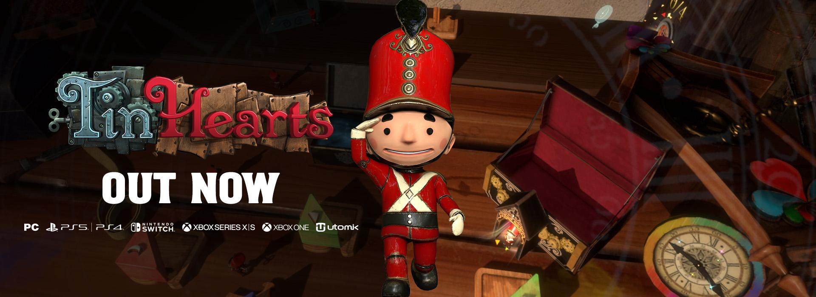

Wholesome Narrative Puzzle Adventure Tin Hearts Launches with Haunting Cover of 80s Classic Toy Soldiers by Martika

Step by Step, Heart to Heart, Left, Right, Left, We all Fall Down
Like Toy Soldiers…

Watford, UK - 16th May, 2023: Publisher Wired Productions and Rogue Sun, crafters of artisanal interactive entertainment, are proud to announce that the immersive narrative puzzle adventure, Tin Hearts, is out now. Singer Aisha Vaughan delivers a stunning performance for the launch trailer as Tin Hearts Releases on PC, PlayStation 4, PlayStation 5, Xbox One and Xbox Series S|X. Find out where to purchase via the Wired Productions website.

To celebrate the launch of Tin Hearts, which last week saw an animated prequel story narrated by legend Stephen Fry, Artists Aisha Vaughan and Kieron Pepper collaborated with Black Razor Records, the indie music label founded by Wired Productions, to create a cover of iconic 80s track “Toy Soldiers” by Martika. The devastating beautiful track perfectly encapsulates the emotion of Tin Hearts, winner of the ‘Most Anticipated Nintendo Switch Game’ accolade during Gamescom 2022.

Watch the Exclusive Launch Trailer:
https://youtu.be/ibPbMnitqlk

Tin Hearts is an immersive, narrative-based, puzzle adventure wrapped up in a powerful tale of love and compromise. March through and solve increasingly elaborate puzzles to unravel a deeply emotional story spanning generations and dimensions, masterfully woven into the fabric of an alternative-Victorian world.

Leo Zullo, Managing Director of Wired Productions, said “Toy Soldiers by Martika is such an iconic song, but if you actually listen to the lyrics, it perfectly reflects the story of Tin Hearts. It was an instant decision to get Black Razor Records to create a new version that matches the emotion of the game perfectly, sung beautifully by the amazing Aisha.”
Kostas Zarifis, Managing Director of Rogue Sun and Tin Hearts' Creative Director, said “It's an emotional time for us! Our baby gets to spread its wings on all platforms! We've released some awesome trailers leading up to this point, but we always knew we wanted to do something truly special for this one.
During development we'd often semi-jokingly play "Toy Soldiers" on different occasions; it's been our sort of team anthem, for obvious reasons. When Wired came to us with the idea of using it on the launch trailer we were ecstatic! Our creative juices started flowing and we immediately got to work! Today we're super proud to share with you not just the final game, but this launch trailer, which we feel perfectly captures the emotional journey Tin Hearts will take you on”

Purchase physical and digital versions via the Wired Productions website. Tin Hearts launches today on PC (Steam, Epic Games Store, GOG, Utomik), PlayStation 4 & 5, and Xbox consoles, following its Nintendo Switch release earlier in April.

PCVR, Meta Quest 2 and PSVR2 are set to be released later this year.

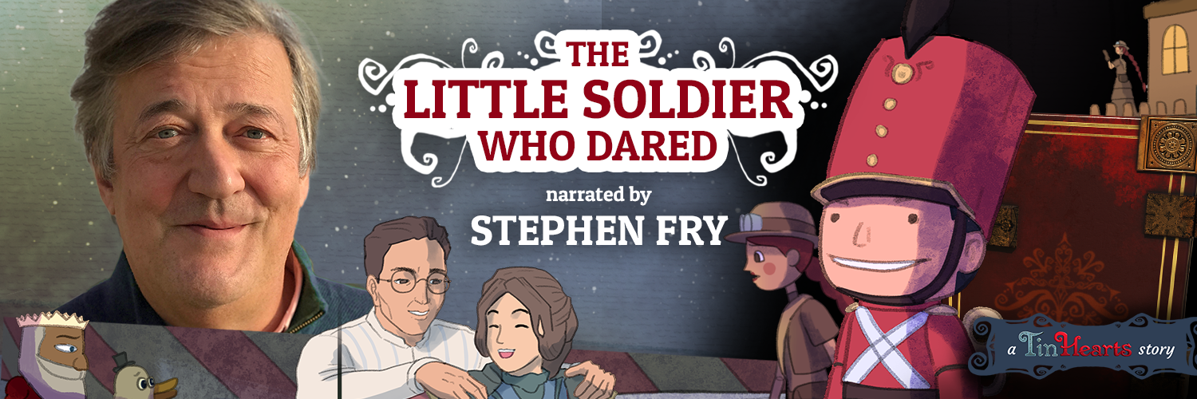

Launched just prior to this week's PC and console release, Stephen Fry narrated the animated prequel, The Little Soldier Who Dared. Albert, an inventor of Victorian times, and his daughter Rose travel to a toymaking convention to show off their wares and have an important meeting, the outcome of which could forever change their destiny. Albert's toys however are special in ways unknown even to him! What goes on at night when the convention hall is emptied of its crowds? And if Albert gets his wish, will it be quite what he was expecting? The Little Soldier Who Dared is narrated by legend Stephen Fry, written by Kostas Zarifis and Mike Faraday, Art by Taufiq Permana, Animation by Thor Hayton and Sound & Music by Matthew Chastney.

Watch The Little Soldier Who Dared: https://youtu.be/vPwNZ_4cvQ8

Search @TinHeartsGame on Twitter and Discord. Find out where to buy or wishlist now via the Wired Productions website.

Download all assets via: https://media.wiredproductions.com/

Request Review Code via: https://requestkey.net/TinHearts

###

PR Contacts:

Renaissance PR
Stefano Petrullo – Renaissance PR
Stefano@renaissancepr.biz
+44 (0) 7828 692 315
Sam Faulkner – Renaissance PR
Sam@renaissancepr.biz

Renaissance PR
wired@renaissancepr.biz

Wired Productions
Anastasia Denisova
press@wiredproductions.com

About Wired Productions

Wired Productions is an independent video games publisher based in Watford, UK. Wired has produced and published award-winning titles across all major platforms and its games are curated to deliver on its mantra: ‘Driven by Passion.’ Bringing games to market in both physical and digital media, recent notable launches include Tin Hearts, The Last Worker, Tiny Troopers: Global Ops, Arcade Paradise, Martha Is Dead, The Falconeer, and Deliver Us The Moon. Upcoming titles include Tin Hearts, The Last Worker, Gori: Cuddly Carnage, Hotel Architect and Bulwark: Falconeer Chronicles.
Find @WiredP on YouTube, Discord, and Twitter or search Wired Productions on Google.
About Rogue Sun

Rogue Sun was formed in May 2016 soon after the closure of historic UK based Lionhead Studios. The founding team all worked on multiple Fable games together, and formed the studio out of a shared passion to create innovative, thoughtful and memorable gameplay experiences. Games with interesting mechanics, meaningful stories, beautiful aesthetics and multi-layered characters.

About Black Razor Records
Black Razor Records launched in 2022 and is a wholly owned label of Wired Productions. Its mission is to bridge the gap between the video game and music worlds and to provide music creators a platform to showcase and commercialise their talent. All music originates from video games, whether in-game or for promotional purposes. By collaborating with great writers and producers, the loadout is complete. Music is in the DNA. Game on!

For more information visit: www.BlackRazorRecords.com

About Aisha Vaughan
Aisha Vaughan is a singer/composer and producer currently based in Elan Valley, Wales. Influenced by Sci-fi, Fantasy and Science, Aisha creates a musical landscape that is unique, dark and beautiful. Electronic beats and synth textures suffused with organic elements and powerful vocals creates music that is inspiring, soulful and masterfully arranged.

###

