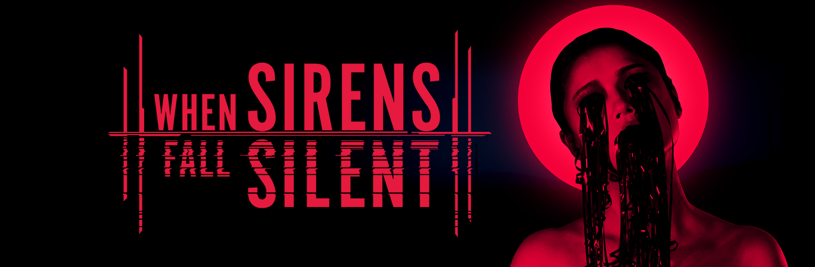
WHEN SIRENS FALL SILENT UNVEILED
From The Teams That Brought You ‘The Town of Light’ & ‘Martha Is Dead’
Comes A Violent, Emotional And Deeply Harrowing Psychological Thriller
Watford, United Kingdom – 4th December 2025 – Psychological horror specialists Wired Productions and LKA today unveiled their third collaboration - When Sirens Fall Silent - a dark, investigative, psychological thriller located in the suburbs of Rome, set in the early 1990s.
In When Sirens Fall Silent, LKA continues its tradition of perfectly recreating real Italian locations, whilst delivering a haunting and uncomfortable narrative unseen before in video games. The studio has consistently tackled difficult topics head-on and this latest project will not shy away from storytelling that pushes the boundaries of art. There will be no face peeling… this is a different kind of horror.
Both The Town of Light and Martha Is Dead were critically acclaimed and won multiple awards, and When Sirens Fall Silent will reveal deep links and crossovers to previous LKA games, further strengthening writer and creative director Luca Dalcò’s credentials as master of shining a light on the forgotten people, continuing the Storie Senza Voce series.
Pushing Unreal Engine 5 to its limits, When Sirens Fall Silent stretches technological boundaries and redefines the expectations of what is possible with a small, but focused team of ten, but also allowed LKA to deliver a new aspect to its games; a branching, multi-layered narrative dialogue system, with a huge focus on verbal and emotional interaction, investigation and subsequent choices; a huge transformation between earlier games.
Watch the first in a series of innovative trailers, that immerses viewers into LKA’s world from the News Media’s perspective, creating a striking, concept-driven exploration of the game’s universe.
Watch the trailer here: “Act1 | The Kidnapped”
https://youtu.be/WlnKzzJyDiw
When Sirens Fall Silent is a dark, investigative, psychological thriller where you play as Mila, a determined policewoman in early 1990s Italy. Haunted by a past she's desperate to escape, Mila is thrust into a high-profile case of kidnappings and murders. As the investigation unravels, you must not only save her from herself, but also being swallowed up by a vortex of violence, mystery and confusion.

When Sirens Fall Silent is now available to be wishlisted on Steam and Epic Game Store.
To stay informed about the latest updates, visit When Sirens Fall Silent, and register your details, or be part of the discussions, @Reddit, @Discord, @X & @Tiktok.

End…
For all press and media enquiries, please contact: press@wiredproductions.com
Press kit: https://media.wiredproductions.com/games/when-sirens-fall-silent/
About Wired Productions
Wired Productions is a true Indie Publisher proudly presenting a diverse range of specially curated games from some of the greatest storytellers and independent developers. Named as “Indie Publisher of the Year” at the MCV / Develop Awards. Wired has an award-winning collection of titles including Hotel Architect, KARMA: The Dark World, Gori: Cuddly Carnage, Bulwark: Falconeer Chronicles, Martha Is Dead. Announced upcoming titles are BrokenLore: DON’T LIE, Task Time and Aaero2: Black Razor Edition.
Find @WiredP on YouTube, Discord, and X or search Wired Productions on Google.
About LKA Studio
LKA Studio are a multi-award winning independent Italian development studio, founded by Luca Dalcò, and are the creators of the critically acclaimed games, The Town of Light and Martha Is Dead. LKA are based in Florence, Italy, and are masters of multi-layered narrative experiences, that are based on real Italian locations and covering specific periods of time – all authentically recreated. The team have also made it a mission to focus on hard-hitting topics that shine a light on the forgotten people, and not to run away from them.
Creative Europe
When Sirens Fall Silent is co-funded by the European Union through the Creative Europe Programme.
==================================================================================

WHEN SIRENS FALL SILENT
Short Description:
When Sirens Fall Silent is a dark, investigative, psychological thriller where you play as Mila, a determined policewoman in early 1990s Italy. Haunted by a past she's desperate to escape, Mila is thrust into a high-profile case of kidnappings and murders. As the investigation unravels, you must not only save her from herself, but also being swallowed up by a vortex of violence, mystery and confusion.
Key Features:
From the creators of The Town of Light and Martha Is Dead – the award winning titles that launched LKA to critical and fan acclaim.
Multi-layered narrative, covering tough topics – from real world issues of trafficking, to real life attitudes of misogyny, the team pull no punches. with a few surprises along the way.
Investigate – find and piece together the clues to hunt down the criminal mastermind, from examining bodies to rooms full of potential answers.
Interview key characters – engage in detailed dialogues but pay attention to the body language, sometimes there are answers in the unspoken words.
Cinematic look & feel – stunning environments and characters, perfectly and authentically recreated for a truly immersive experience.
Environmental puzzles – from the logical to the mind bending, but all to add challenges to your journey.
Explore & re-explore to uncover more clues – crime scenes often hide clues that aren’t obvious on first examinations… who knows what you might find.

